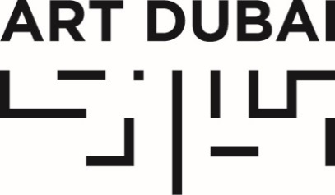
For immediate release
June 1, 2016

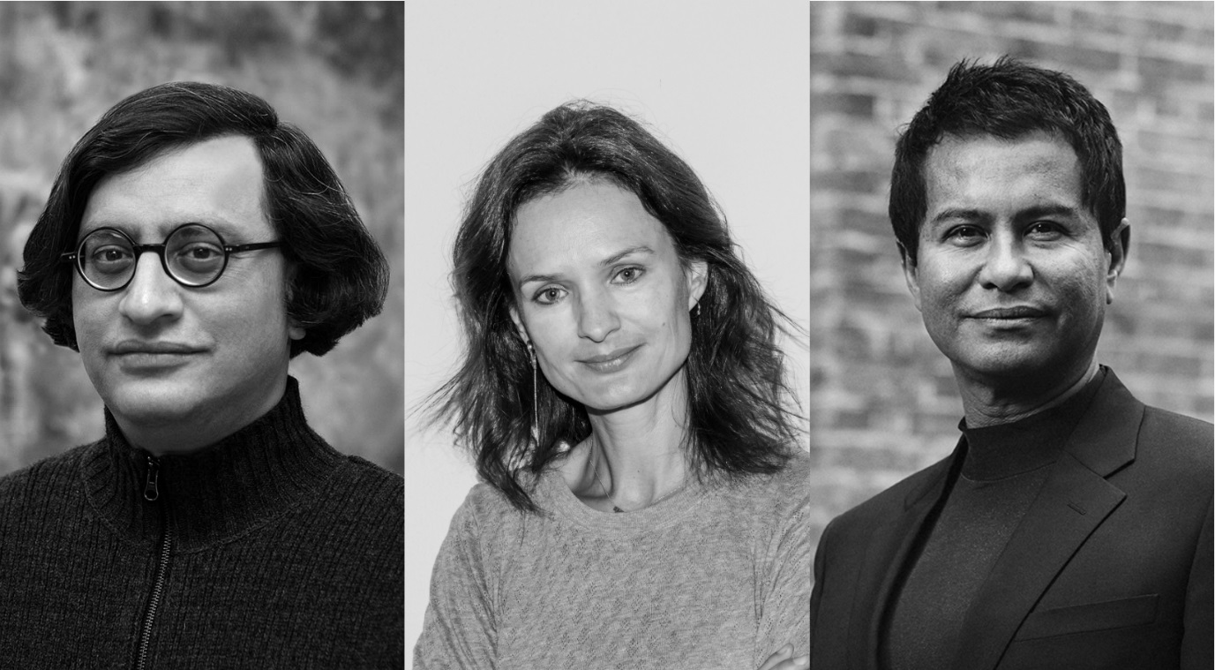

ART DUBAI ANNOUNCES NEW SELECTION COMMITTEE MEMBERS AHEAD OF GALLERY OPEN CALL

- Three new members to Art Dubai’s gallery Selection and Advisory Committees
- Glenn Scott Wright (Co-Director, Victoria Miro, London) and Isabelle van den Eynde (Gallery Isabelle van den Eynde, Dubai) will join the Selection Committee for Art Dubai Contemporary
- Cornell University’s Iftikhar Dadi joins the Advisory Committee for Art Dubai Modern

JUNE 1 2016, DUBAI UAE – Following the record successes of its tenth anniversary edition in March 2016, Art Dubai is delighted to announce three new members to its gallery Selection and Advisory Committees. The additions include two major international gallerists and a leading art scholar—all with strong ties to the Middle East, North Africa and South Asia art scenes. The announcement comes ahead of the competitive gallery open call for the fair’s eleventh edition, taking place March 15-18, 2017 at Madinat Jumeirah.

Co-director of Victoria Miro (London) Glenn Scott Wright and Isabelle van den Eynde (Gallery Isabelle van den Eynde, Dubai) will join longtime friends of the fair Andrée Sfeir-Semler (Sfeir-Semler Gallery, Hamburg / Beirut) and Ursula Krinzinger (Galerie Krinzinger, Vienna) on the Selection Committee for Art Dubai Contemporary, while Cornell University’s Iftikhar Dadi joins the group of renowned curators and art historians Savita Apte, Catherine David, Kristine Khouri and Nada Shabout on the Advisory Committee for Art Dubai Modern, which remains the only gallery programme of its kind, presenting works by the modern masters of the Middle East, Africa and South Asia.

Art Dubai has become known as a global meeting point in the art world, one that each year draws a distinct constituency of artists, curators, collectors, institutional directors and gallerists with a special interest in the art scenes of the region and beyond. The fair remains committed to a rigorous selection process and thoughtful curatorial approach across its gallery programmes: the Contemporary section includes two gallery programmes (Solo, for one or two-artist presentations, or Collective, for more than two artists) while Art Dubai Modern keeps its intimate and highly curated feel, with up to fifteen select presentations.

Myrna Ayad, Fair Director, said: “We’re delighted to welcome Glenn and Isabelle to the Art Dubai Contemporary Selection Committee and Iftikhar to the Art Dubai Modern Advisory Committee. Their renown and expertise in the international art world, coupled with their deeply personal commitments to the region’s art arena, make them exceptional additions to the fair.”

—END—

MEDIA CONTACTS
International media contact Local and regional media contact
Victoria Mitchell Alia Gilbert
SUTTON Communications Manager, Art Dubai
victoria@suttonpr.com alia@artdubai.ae
+44 (0) 20 7183 3577 +971 971 4 563 1405

NOTES TO EDITORS
About Art Dubai Modern
Art Dubai Modern is devoted to modern art from the Middle East, Africa and South Asia, presented by regionally and internationally based galleries. Each exhibitor presents a solo or two-person show, featuring works by modern masters of the twentieth century, with a focus on work produced between the 1940s and 1980s. Galleries are asked to submit proposals for booth exhibitions by artists whose work has proven highly influential during the last century and on later generations of artists, and are encouraged to focus on a particular period or theme within an artist’s practice.
Art Dubai Modern’s Advisory Committee reviews all applications and the final selection is based on the curatorial strength of the gallery exhibition programme and the gallery’s submitted proposal.

About Art Dubai Contemporary
Art Dubai Contemporary features 70 to 75 galleries, from the world’s most influential galleries to dynamic young art spaces. Likewise, exhibited artists range from emerging practitioners from lesser-known art capitals to household names. The works they present cover all artistic media, including painting, drawing, sculpture, installation, video, photography and performance.
Art Dubai Contemporary features commercial galleries operating on the primary market that have been established for at least two years. Galleries interested in the 2017 edition of the fair are asked to submit an online application form that includes a curatorial proposal for the booth for one of the two Contemporary gallery programmes: Collective—the main section of Art Dubai Contemporary, with multi-artist presentations—and Solo, a section focusing on solo and two-artist shows. All applications are reviewed by Art Dubai’s Selection Committee with the final selection based on the curatorial strength of the proposal and of the gallery’s exhibition programme.

About Art Dubai
Art Dubai is held under the Patronage of HH Sheikh Mohammed bin Rashid Al Maktoum, Vice President and Prime Minister of the UAE and Ruler of Dubai.

Art Dubai is held in partnership with The Abraaj Group and is sponsored by Julius Baer and Piaget. Madinat Jumeirah is home to the event. The Dubai Culture & Arts Authority (Dubai Culture) is a strategic partner of Art Dubai and, along with Dubai Design District (d3), supports the fair’s year-round education programme.

Art Dubai 2016 included 94 galleries, presented across three programmes – Contemporary, Modern and Marker. Art Dubai’s extensive not-for-profit programme includes Art Dubai Projects; an exhibition of works by winners of the annual Abraaj Group Art Prize; a range of educational programmes including the Sheikha Manal Little Artists Program and the community school Campus Art Dubai, and the critically acclaimed Global Art Forum.

The eleventh edition of Art Dubai takes place March 15-18, 2017.

artdubai.ae | Twitter | Facebook | Instagram

