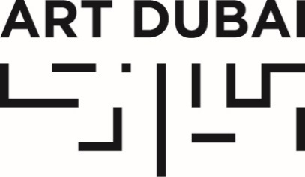

For immediate release
October 31, 2017

ART DUBAI ANNOUNCES 2018 GALLERY LINE-UP AND LAUNCH OF NEW GALLERY SECTION IN ITS LARGEST AND MOST INTERNATIONAL EDITION TO DATE

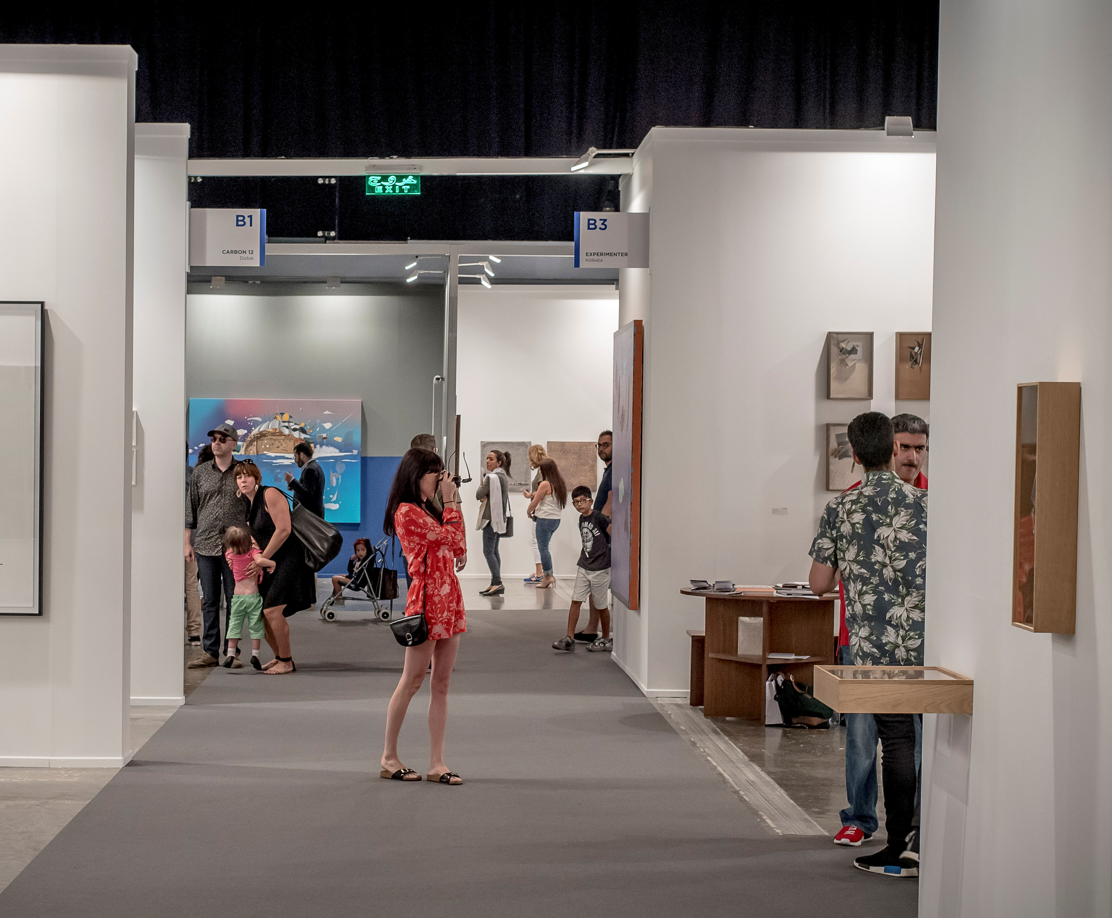
Art Dubai Contemporary 2017. Courtesy Photo Solutions.

OCTOBER 31, 2017, DUBAI, UNITED ARAB EMIRATES – Art Dubai announced today the gallery line-up for its 2018 edition, as well as the launch of a new section entitled Residents, which will debut at the fair next year.

Held under the patronage of HH Sheikh Mohammed bin Rashid Al Maktoum, Vice President and Prime Minister of the UAE and Ruler of Dubai, and in partnership with The Abraaj Group, Art Dubai 2018 will feature a record 104 galleries from 47 countries, making the coming edition the fair’s largest and most globally diverse to date. Alongside 77 returning galleries, the fair will welcome 27 first-time exhibitors from around the world.

Confirming its unique identity as a place of discovery and a meeting point for art from established centers of the international art world and emerging scenes alike, Art Dubai’s Contemporary section will feature 78 galleries from 42 countries in 2018, including first-time participations from Iceland, Ethiopia and Kazakhstan.

The fair’s 2018 edition will also see the launch of Residents, a one-of-a-kind 4-8 week residency programme for international artists, invited to the UAE to immerse themselves in the local art scene, to create a body of work which merges their distinct artistic practice with their surroundings. The final works will be on show in the new section of the fair, presented by the artists’ respective galleries.

Pablo del Val, Art Dubai’s Artistic Director commented: “With every edition, Art Dubai asserts itself as the world’s most international art fair and the diversity coming through participating galleries from 47 countries is testament to this. For our 2018 edition, we will be launching Residents, a pioneering and unique platform that brings together different energies, synergies, geographies and artistic practices, which one doesn’t usually see together in one place.”

Celebrating its fifth edition in 2018, Art Dubai’s Modern section remains the only commercial platform in the world to showcase museum-quality works by artists from the Middle East, Africa and South Asia.

Art Dubai’s Director Myrna Ayad commented: “It is very exciting for us to witness the growing appreciation of Modern Masters from the region, and we are pleased to be the only platform in the world to showcase these museum-quality pieces in our largest-ever Modern section, which has been the most oversubscribed edition to date. Serving as an educational platform and theoretical framework for the works on show, Art Dubai Modern will be accompanied by our second annual Modern Symposium at the fair this year.”

Art Dubai is sponsored by Julius Baer, Meraas and Piaget. The fair’s 12th edition will take place March 21-24, 2018 at its home Madinat Jumeirah.

CONTEMPORARY

Spread across two gallery halls, Art Dubai Contemporary 2018 will feature 32 galleries in its Solo section – a section focused on solo- and two-artist presentations – and 46 galleries in Collective, which is dedicated to multi-artist shows, with both sections mixed across the two Contemporary halls.

2018 will see a significant contingent of returning galleries from Europe and North America, including Marianne Boesky Gallery (New York, Aspen), Galerie Daniel Templon (Paris, Brussels), Galerie Krinzinger (Vienna), Victoria Miro (London, Venice), Gallería Continua (San Gimignano, Beijing, Les Moulins, La Habana) and Galleria Franco Noero (Turin), which will exhibit alongside first-time participants Galería Elba Benítez (Madrid), i8 Gallery (Reykjavík) and Galerie Mitterrand (Paris), amongst others.

The strong representation of galleries from the Middle East, North Africa and South Asia, is testament to Art Dubai’s role as a driving force in the development of the art scene of the wider region and its market. The diverse line-up from across the Middle East and North Africa includes Sfeir-Semler Gallery (Beirut, Hamburg), Athr Gallery (Jeddah), Galerist (Istanbul), Selma Feriani Gallery (Tunis, London), Gypsum Gallery (Cairo), Voice Gallery (Marrakech), Agial Gallery (Beirut) and Galerie Tanit (Beirut, Munich), who will exhibit alongside Experimenter (Kolkata) and Canvas Gallery (Karachi) from South Asia.

African art will feature prominently at the 12th edition in both the gallery halls and the Residents section, Art Dubai will welcome Gallery 1957 (Accra), Addis Fine Art (Addis Ababa, London), Tafeta, (London), and Officine dell’Immagine (Milan), amongst others.

In addition, the fair continues to hold a unique presence of galleries from Latin America such as Piero Atchugarry Gallery (Pueblo Garzón), Revolver Galeria (Lima, Buenos Aires), Galeria Vermelho (Sao Paulo) and Henrique Faria Fine Art (Buenos Aires, New York).

View the full list of participating galleries for Art Dubai Contemporary 2018 here.
High-resolution visuals for Art Dubai Contemporary 2018 are available for download here.

MODERN

An indicator of its ongoing success, Art Dubai Modern 2018 will feature a record number of 16 galleries exhibiting artists from 14 countries. For the first time, Art Dubai Modern will offer the opportunity to see galleries present tightly curated collective exhibitions, in addition to solo and two-artist shows.

Participating galleries will present renowned Modernists from the Middle East such as Gebran Tarazi (1944-2010), represented by Agial Art Gallery (Beirut), prolific Egyptian Post-War artist Abdel Hadi El Gazzar (1925-1966), showcased by Karim Francis Gallery (Cairo), as well as works by Iranian-American artist Manoucher Yektai (b. 1922), shown by Aria Gallery (Tehran). First-time participating gallery Mark Hachem Gallery (Paris, Beirut, New York), will present works by Lebanese artists Alfred Basbous (1924-2006) and Helen Khal (1923-2009), alongside Egyptian Hamed Abdalla (1917-1985).

Pieces by leading Modernists from South Asia will be exhibited by Grosvenor Gallery (London), DAG Modern (New Delhi, Mumbai, New York) and newcomer Sanchit Art Gallery (New Delhi), all of whom will present collective exhibitions of works by masters from India and Pakistan, among them M.F. Husain (1915-2011), Zahoor ul Akhlaq (1941-1999), Anwar Jalal Shemza (1928-1985), Ganesh Pyne (1937-2013) and G.R. Santosh (1929-1997), among other renowned South Asian modernists.

Perve Galeria (Lisbon) will present works by Cape Verdean artist Manuel Figueira (b. 1938) and Mozambican artists Ernesto Shikhani (1934-2010) and Reinata Sadimba (b. 1945), amongst others. Elsewhere from the African continent, newcomer Ubuntu Gallery (Cairo) presents a group show of works by celebrated Egyptian modernists including Gazbia Sirry (b. 1925), Tahia Halim (1919-2003) and Mohammed Naghi (1888-1956), among others. Tunisian galleries Le Violon Bleu (Tunis) and Elmarsa (Tunis, Dubai), will show solo shows for Ali Bellagha (1924-2006) and Mahjoub Ben Bella (b. 1946) respectively.

View the full list of participating galleries for Art Dubai Modern 2018 here.
High-resolution visuals for Art Dubai Modern 2018 are available for download here.

RESIDENTS

Residents 2018 will present an intimate selection of 10 solo gallery presentations by artists from around the world working across all media. The galleries in this section will be presented in a special exhibition between the two Contemporary gallery halls.

The programme aims to support artists by providing a platform to develop their practice and create new work inspired and influenced by their stay in the UAE. Framed within a unique geographical and cultural context, Residents further aims to facilitate exchange and dialogue between artists, local communities and the broader cultural landscape.

During the residency, artists will have the opportunity to engage with the local community, work collaboratively with one another, participate in talks and conduct open studios. Further details around this will be announced soon.

Residents will present a diverse artist line-up including Ghanaian-German artist Zohra Opoku (Mariane Ibrahim Gallery, Seattle), Lithuanian artist Kristina Alisauskaite (The Rooster Gallery, Vilnius), Indonesian artist Piko Iabadiou (Orbital Dago, Bandung), and Turkish artist Jennifer Ipekel (Öktem&Aykut, Istanbul), amongst others.

View the full list of participating artists in Art Dubai Residents 2018 here.
High-resolution visuals for Art Dubai Residents 2018 are available for download here.

—END—

MEDIA CONTACT
Nicole Kanne
Art Dubai
nicole@artdubai.ae

NOTES TO EDITORS

About Art Dubai
Taking its distinct identity from a one-of-a-kind line-up of 103 galleries from 47 countries, exhibited across its gallery halls and Residents section, Art Dubai aims to broaden the conversation on art outside of the traditional art centers. It does so by featuring galleries and artists presenting works from emerging art scenes, exhibited alongside, and matching the quality of, those from firmly established centers of the art world, making the fair a place of discovery from art from across the globe.

Mirroring the cosmopolitanism and energy of its hometown Dubai, Art Dubai is a human-scale fair that acts as a meeting point for the international art world. A manifestation of this is the fair’s museum groups programme, which has served as a platform for discussions and networks that last in time and go beyond commercial transactions, and has seen the inception of international exhibitions and artistic projects that crystallize throughout the year.

A leading international art fair, Art Dubai is also the preeminent place to interact with art from the Middle East, North Africa and South Asia through a number of high-profile galleries from across the region. In addition, the fair features a unique section, showcasing museum-quality Modern works from the MENASA region, alongside a yearly Modern Symposium.

Acting as a digital extension of Art Dubai’s offering, the Art Dubai Portraits, a film series on artists that are connected to the fair through its programming or participating galleries, serve as a one-of-a-kind resource for curators and researchers working on the art from the region.

Art Dubai further promotes regional art and artists by featuring a unique mix of programming and commissioned works, often in partnership with other regional institutions, as well as the annual exhibition of works by the winner and shortlisted artists of the Abraaj Group Art Prize.

Through its year-round educational initiatives such as the Global Art Forum, Campus Art Dubai and the Art Dubai Fellowship, Art Dubai is integral to the development of the local art scene and is active in building the theoretical framework for the local artistic talent showing at the fair.

Art Dubai is held in partnership with The Abraaj Group. The fair is sponsored by Julius Baer, Meraas and Piaget. Madinat Jumeirah is home to the event. The Dubai Culture & Arts Authority (Dubai Culture) is a strategic partner of Art Dubai and supports the fair’s year-round education programme.

artdubai.ae

Twitter | Facebook | Instagram | #ArtDubai2018

Art Dubai 2018 Selection and Advisory Committees
The Selection Committee for Art Dubai Contemporary 2018 includes Ursula Krinzinger (Galerie Krinzinger), Andrée Sfeir-Semler (Sfeir-Semler), Isabelle van den Eynde (Gallery Isabelle van den Eynde), and Glenn Scott Wright (Victoria Miro). Independent curators Sam Bardaouil and Till Fellrath joined the Committee as guest curators.

Applications for this edition of Art Dubai Modern were overseen by an Advisory Committee comprising Dr. Nada Shabout, Professor of Art History and the Coordinator of the Contemporary Arab and Muslim Cultural Studies Initiative (CAMCSI) at the University of North Texas, Dr Iftikhar Dadi, Associate Professor in Cornell University’s Department of History of Art and Chair of its Department of Art, Catherine David, Deputy Director, Musée National d'Art Moderne, Centre Pompidou, and the Committee’s newest member Vali Mahlouji, a London-based curator, founder of the non-profit research and curatorial platform Archaeology of the Final Decade and independent advisor to the British Museum.

