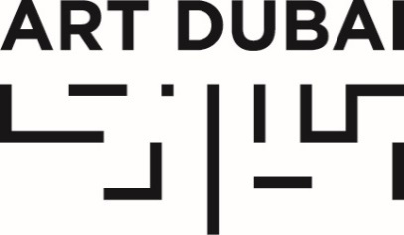

Press Release
Date of issue: January 24, 2018

FULL PROGRAMME FOR THE GLOBAL ART FORUM 2018 ANNOUNCED

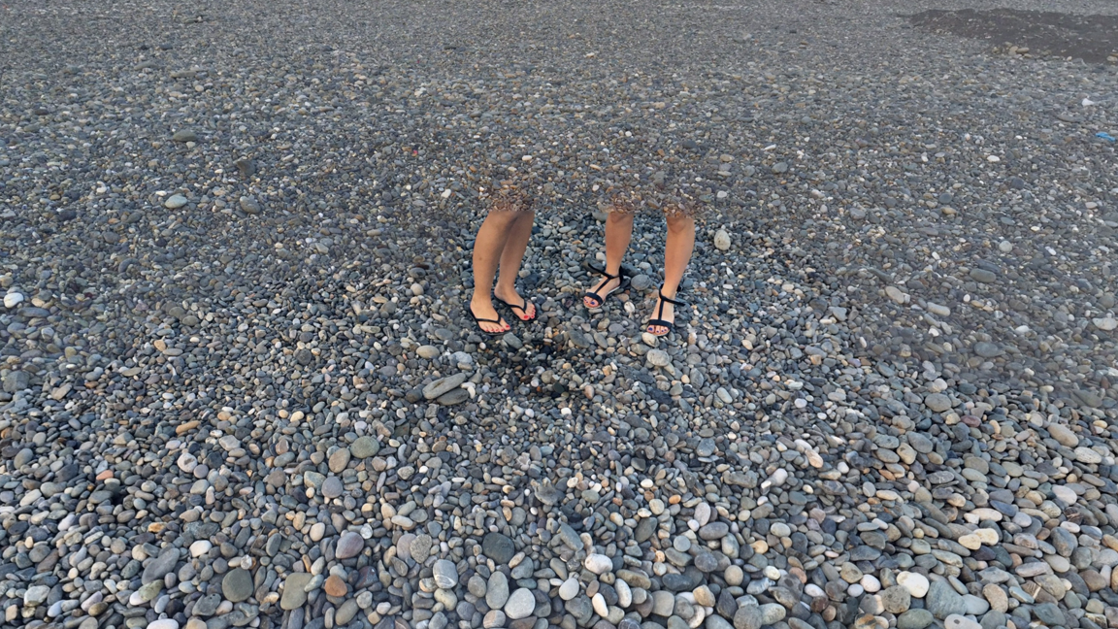
Legend, originally uploaded to Google Street View by Arthur Star. (Kyle Williams via Google Maps)

JANUARY 24, 2018, DUBAI, UNITED ARAB EMIRATES – Art Dubai announced today the full programme for the 12th edition of the Global Art Forum, taking place in two sessions in February and March this year. Entitled ‘I Am Not A Robot’, the current edition of the Forum will explore the highly topical theme of automation – as well as the opportunities and trepidations brought along with it.

Part of Art Dubai’s extensive cultural programming, the Global Art Forum is an annual arts conference – the largest in the Middle East, North Africa and South Asia – and unique in that it examines culture from a variety of disciplines as well as in bringing together leading minds from a variety of fields to discuss a specific topic. Both sessions of the Global Art Forum are open to the public and free to attend.

The opening session of the Global Art Forum 2018 will take place on Wednesday, February 14, 2018 at Dubai Design District, introducing some of the key themes of ‘I Am Not A Robot’, in a series of talks, presentations and discussions with Shumon Basar, Noah Raford, Marlies Wirth and acclaimed artist/writer James Bridle, who Buzzfeed ranked 3rd in its list of “11 Tech Heroes of 2017 who aren’t CEOs”.

The Forum will continue at Art Dubai from Wednesday, March 21 – Friday, March 23, 2018 for its acclaimed three-day marathon, exploring the impacts of automation, Artificial Intelligence and machine learning in work, creativity, design, economics, politics and art. Some of the pressing questions posed are: “Is there a Non-Western model of AI?”, “Will the blockchain build a new Internet?”, “What makes us human in an increasingly non-human world?”, and “What are machines saying about us behind our backs?” In addition to lectures, conversations and discussions, there will be performances and a rich cinema-screening programme by Cinema Akil.

The 2018 iteration of the Global Art Forum is organized by Commissioner Shumon Basar, with with Chief Operating Officer and Futurist-in-Chief of the Dubai Future Foundation Noah Raford, and Curator of Digital Culture & Design Collection at the MAK, Vienna, Marlies Wirth, as Co-Directors.

Art Dubai’s Global Art Forum is presented by the Dubai Culture and Arts Authority (Dubai Culture) and supported by Dubai Design District (d3).

GLOBAL ART FORUM 12: FULL PROGRAMME

Wednesday, February 14
Dubai Design District, between Building 8 and 9

6:30-6:40pm WELCOME AND INTRODUCTION
By Global Art Forum Commissioner Shumon Basar and Co-Directors Noah Raford and Marlies Wirth

6:40-6:50pm I AM SHE: SOME FEMALE AUTOMATA FROM CINEMA
PRESENTATION
Shumon Basar
Cinema — that 20th century mass art form — provides one of the most fertile settings for history’s enduring experiments with man-made women. Shumon Basar outlines a brief genealogy and draws upon examples from the films Metropolis, Alphaville, Blade Runner (and its recent sequel Blade Runner 2049), Ex Machina and a few Scarlett Johansson-led titles. What are the cultural and psychological values invested in cinema’s female robots? And why are men so scared?

6:50-7:00pm I AM AI DIPLOMAT: ALIEN PROTOCOLS AND INTERNATIONAL RELATIONS OF THE MIND
POLEMIC
Noah Raford
According to some, we are within a decade of the arrival of artificial general intelligence; machines so powerful that they can do anything a human being can, but faster, better, and more accurately. How will we handle the arrival of such a phenomena? How might this impact our world and what ways should we be thinking about possible responses? This whimsical talk explores serious issues through the lens of aliens, international relations, and medieval diplomacy to help us better understand the landscape we may face in the future.

7:00-7:15pm ARE WE ARTIFICIAL: TWO RECENT EXHIBITIONS
LECTURE
Marlies Wirth
Hello Robot and Artificial Tears were two recent exhibitions in Vienna, which dealt with the complex issues around automatization. Hello Robot looked at how design shapes our relationship with technology and with each other. Artificial Tears took a science-fiction position: asking what makes us “human” in this day and age, or if we are “artificial” after all. Co-curator Marlies Wirth talks us through both shows, and how these kinds of technologies are increasingly entering museum space in unexpected ways.

7:15-8:00pm I AM A HUMAN ARTIST
PRESENTATION AND DISCUSSION
Artist and Writer James Bridle, hosted by Shumon Basar, Noah Raford and Marlies Wirth
How are artists engaging with technologies of automation, as well as the ever increasing automation of the world? With a background in linguistics and Artificial Intelligence, the artist James Bridle has dealt with predictive big data, drones, and the ethical problems posed by YouTube. Here, he discusses his ideas and work, and the social and political concerns facing the current moment.

Wednesday, March 21
Art Dubai, Madinat Jumeirah, Fort Island

2:00-2:15pm WELCOME AND INTRODUCTION
Shumon Basar with Noah Raford and Marlies Wirth

2:15-2:45pm I AM AI
LECTURE
Media Theorist Paul Feigelfeld
What are the apocryphal histories of computing, and artificial/machine intelligence? Its obscure layers and lairs? The cryptic and alien languages it speaks? And the images it imagines but we cannot see? In this lecture, we’ll look for the Cloud at the bottom of the oceans and for platforms in the skies. We’ll travel the land of the blind and go mind jogging in China.

2:45-3:45pm I AM NOT WESTERN AI: ANIMALS, ALIENS, AND ALTERNATE PHILOSOPHIES OF MIND
DISCUSSION
Assistant Professor, Academy of Media Arts Cologne Mi You, National Technology Officer Microsoft China Ltd. Qing Wei, Professor, Department of Philosophy, Autonomous University of Barcelona Jordi Vallverdú, hosted by Noah Raford
How do intelligence, cognition, and concepts of the self vary across cultures (and species)? How might this influence the development of AI? From robot monks in Japan that hold perpetual prayers, to octopus consciousness and multi-bodied minds, the creation of perceiving machines will reflect deeply on our sense of self, and indeed, life itself.

3:45-4:15pm AM I STILL EMPLOYED: JOBS, JOYS, AND WHAT DO YOU DO
LECTURE AND CONVERSATION
Writer Mishaal Al Gergawi with Head of Research, Dubai Future Foundation Jessica Bland
Work titles are our insignia, our shared points of societal reference. How will the “unnecessary rest” begin to define themselves if the rich eventually fund basic income? Communism tried to eliminate economic hierarchy only to replace it with a power-based hierarchy. What will artificial intelligence replace the social order of work with? VR-for-life may not be enough. Do Gulf States have a head start?

4:30-5:00pm I AM AWESOME, ANNOYING AND AWFUL: AI IN EVERYDAY LIFE, 2050
CONVERSATION
Product and Interaction Designer Simone Rebaudengo with Noah Raford
AI will take many forms in the future, from self-selling disposable goods to terrifying, continent-wide minds that shape entire industries. How will these minds interact with our everyday goods and experiences? Will it be awesome, annoying, or awful? A pantheon of negotiation, a paradise of domination, or a compound of complication?

5:00-5:30pm I AM A HYPERSTITION
LECTURE
Artist, Writer and Trend Forecaster Emily Segal
“Hyperstition” was a term coined in the 1990s to describe fictions that make themselves true – a form of automation in their own right. This lecture presents new research from the think-tank Nemesis that recasts the concept of Hyperstition in the contemporary moment, mapping the architecture of hype and its vectors of development.

5:30-6:30pm I AM A HUMAN ARTIST: PART 1
DISCUSSION
Artists Rokni, Ramin Haerizadeh & Hesam Rahmanian, Yuri Pattison and Ania Soliman, hosted by Writer Melissa Gronlund
How are artists engaging with technologies of automation, as well as the ever increasing automation of the world? What new kinds of aesthetics, experiences and knowledge emerge? From interactive puppetry to robot choreography via the unconscious intent of algorithms, these artists discuss their ideas and work, and the complex concerns facing the current moment.

Thursday, March 22
Art Dubai, Madinat Jumeirah, Fort Island

2:00-2:15pm WELCOME AND INTRODUCTION
Shumon Basar with Noah Raford and Marlies Wirth

2:15-3:15pm I AM A HUMAN ARTIST: PART 2
DISCUSSION
Artist and ‘Private Ear’ Lawrence Abu Hamdan with Artists Katja Novitskova and Pamela Rosenkranz, hosted by CTO Serpentine Galleries London and Initiator unMonastery Ben Vickers
How are artists engaging with technologies of automation, as well as the ever increasing automation of the world? What new kinds of aesthetics, experiences and knowledge emerge? From aural surveillance to neuropharmacology via the sculptural qualities of Internet images, these artists discuss their ideas and work, and the accelerated textures of the present moment.

3:15-3:45pm IS IT DJINN: GHOSTS, MACHINES, MUSIC
CONVERSATION
Music Producer and Artist Fatima Al Qadiri and Shumon Basar
Long before Artificial Intelligence arrived, technology has often been framed as a supernatural force. There are maybe more “ghosts in the machine” now than there are human beings in the world. Fatima Al Qadiri’s work, too, is haunted by many things. A Kuwaiti childhood during the first Gulf War shaped a sonic sensibility, which in turn has produced music redolent of war video games and a spirit world. She discusses the links between sound and memory, djinn and the digital.

3:45-4:45pm I AM HUMAN: CAN YOU PROVE IT?
DISCUSSION
Artist and Architect Alessandro Bava with Designer Simone Niquille and Artist and Writer Patricia Reed, hosted by Marlies Wirth
Supranational structures (Google, Amazon, Alibaba) preside over our knowledge and technology. They cunningly manipulate the masses with the use of self-learning algorithms and streamlined filter bubbles. But should our major societal decisions be given over to what Hito Steyerl has described as “Artificial Stupidity”? As we increasingly inhabit responsive environments that attempt to predict our wishes and desires before we even have them, this discussion identifies the shifts in personal and political dynamics, and the role of human agency in a non-human world.

4:45-5:00pm REPORT FROM THE SERPENTINE MARATHON 2017
PRESENTATION
Artistic Director Serpentine Galleries London Hans Ulrich Obrist and Ben Vickers
The 2017 Marathon, entitled “Guest, Ghost, Host: Machine!,” brought together artists, scientists, activists, engineers, poets, sociologists, philosophers, filmmakers, writers, anthropologists, theologians and musicians to consider the advent of “artificial intelligence,” consciousness, interspecies cooperation, trans-humanism and non-linear time. The Marathon sought to illuminate the ways in which these fields of exploration leave unrecognizable traces and unknowable apparitions in the present.

5:00-6:00pm I AM DISTRIBUTED: AT THE FRONTEIRS OF THE BLOCKCHAIN
DISCUSSION
Theorist Jaya Klara Brekke with Architect and Musician Martti Kalliala, hosted by Hans Ulrich Obrist and Ben Vickers
The blockchain is a database validated by a global community and backed by code/math, rather than a central authority. Many claims are made for it: from introducing a new, better Internet to disempowering centralized banks. But what does the geography of the blockchain look like? What are its politics? And what is a "Decentralized Autonomous Rave Scene?" This discussion explores the still-emerging philosophy and technology of the blockchain and the kind of world it might bring about.

6:00-6:30pm I AM/NOT A ROBOT
PERFORMANCE
Artist and Dancer Isabel Lewis and Artist Asad Raza
A playful encounter between crafters of live experience Isabel Lewis and Asad Raza using voice, text, electronic music and vocal processing. Following their open workshop earlier in the day, Raza and Lewis will address the particular agency we could and do have in our current condition as real cyborgs.

Friday, March 23
Art Dubai, Madinat Jumeirah, Fort Island

2:00-2:05pm WELCOME AND INTRODUCTION
Shumon Basar with Noah Raford and Marlies Wirth

2:05-2:45pm AM I A SAD ROBOT: THE CLINIC OF AI
LECTURE
Philosopher and Writer Aaron Schuster
Why are AI's typically portrayed in popular culture as murderous/psychotic, bent on wiping out the human race? Wouldn't intelligent machines run the full range of human psychopathologies? Think of Marvin, the melancholic robot from The Hitchhiker's Guide to the Galaxy. Isn’t it more likely that a hyper intelligent AI would become depressed, not aggressive? Perhaps in the future, the main role of human beings will be to minister therapeutically to depressed AIs, whose melancholic bouts threaten civilization with digital malaise and total breakdown. In this lecture, Schuster explores the "clinic of AI:" the psychopathologies of our machine intelligent future.

3:00-6:00pm CINEMA AKIL PRESENTS “CONSIDER THE ROBOT & ‘OTHER’ STATES OF FUTURENESS”
SCREENINGS AND Q&A
Cinema Akil presents a filmic framework of intersectional imagination. Sci-fi short mockumentary Last Days of the Man of Tomorrow (2017) takes a look at Lebanon’s history through the life and legend of Manivelle, an automaton gifted to the nation in 1945, making it the country’s first AI citizen. In Wanuri Kahui’s sci-fi drama Pumzi (2009), a post-apocalyptic future East Africa is visited, 35 years after World War III. Together, the two sci-fi shorts will unthink Eurocentric depictions of imminent automation. A conversation between Pumzi Director Wanuri Kahui and writer/curator Özge Calafato explores these themes deeper.
Cinema Akil at GAF12 will close with the Middle East premiere of the documentary Free Lunch Society (2017).

—END—

MEDIA CONTACT
Nicole Kanne
Art Dubai
nicole@artdubai.ae

NOTES TO EDITORS

About The Global Art Forum

The Global Art Forum is an annual, transdisciplinary summit, based in Dubai, which combines original thinking and contemporary themes in an intimate, live environment. Since 2007, the Forum has been a key part of Art Dubai’s extensive cultural programming. It has brought together over 400 global minds from pop culture to renowned academia: artists, curators, museum directors, filmmakers, novelists, historians, philosophers, technologists, entrepreneurs, musicians and performers, dialogue with one another across disciplines, reporting from every part of the world, painting a truly 21st century portrait of how the globalized world thinks.
#GAF12

About Art Dubai
A leading international art fair, Art Dubai is the preeminent place to interact with Contemporary art from the Middle East, North Africa and South Asia. For its 12th edition Art Dubai presents a unique line-up of 105 galleries from 48 countries, reaffirming the fair's position as a place of discovery with galleries from new markets rarely seen on the international stage exhibiting alongside leading galleries from established art centers. It will also showcase the largest edition of Art Dubai Modern – the world’s only platform that exhibits museum-quality Modern works from the MENASA region, alongside the annual Modern Symposium of talks on the lives and legacies of artists operating in these regions in the 20th century.

Art Dubai 2018 inaugurates a new gallery section – Residents – that welcomes spaces whose artists will complete a residency in the UAE with work created during this period exhibited at the fair.

Beyond the gallery halls, the fair once again hosts an extensive collateral programme including the 10th anniversary of The Abraaj Group Art Prize, the Global Art Forum that takes on the theme of automation, and a series of commissions including the artist collective GCC, which will welcome audiences to Good Morning GCC at the fair and an engaging after-hours programme, including private visits to collections and to cultural institutions across the United Arab Emirates.

In addition to its March programming, the fair aims to continue to grow the cultural fabric of the city and the region with year round engagement including the art school Campus Art Dubai, an internship programme aimed at supporting the next generation of art practitioners and professionals, and Art Dubai Portraits, a film series casting light on MENASA artists and their practices.

Art Dubai is held in partnership with The Abraaj Group. The fair is sponsored by Julius Baer and Piaget, with Madinat Jumeirah as the home of the event. The Dubai Culture & Arts Authority (Dubai Culture) is a strategic partner of Art Dubai and supports the fair’s year-round education programme. MiSK Art Institute is the exclusive partner of Art Dubai Modern.

artdubai.ae

Twitter | Facebook | Instagram | #ArtDubai2018

