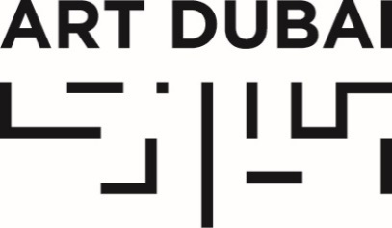

Press Release
Date of issue: March 28, 2018

ART DUBAI’S 12TH EDITION CLOSES AS IT CELEBRATES ITS MOST DIVERSE ITERATION TO DATE

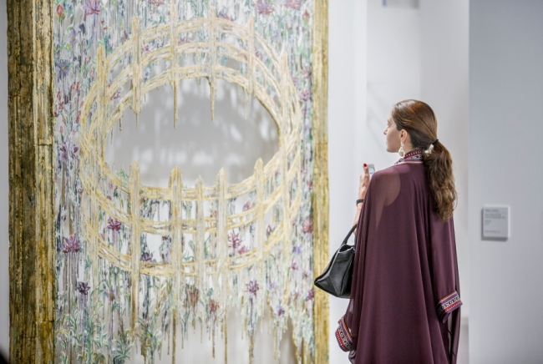
Art Dubai Contemporary 2018. Courtesy Art Dubai and Photo Solutions.

MARCH 28, 2018, DUBAI, UNITED ARAB EMIRATES – The 12th iteration of Art Dubai, held under the patronage of His Highness Sheikh Mohammed bin Rashid Al Maktoum, Vice President and Prime Minister of the UAE and Ruler of Dubai closed this Saturday having welcomed 28,000+ visitors, that included representatives from 106 international museums and cultural institutions and an increase of 18% in ticket sales.

Art Dubai 2018 welcomed 105 galleries from 48 countries across its Contemporary, Modern and Residents sections, including first-time participating countries Ethiopia, Iceland, Ghana and Kazakhstan, marking the fair’s most diverse edition to date and reaffirming its position as the most global of art fairs.

Maria Mumtaz, Director at Gallery Isabelle van den Eynde, one of Dubai’s leading galleries and long-time exhibitor at Art Dubai, commented: “Art Dubai gets better every year and there is such a great mix of regional and international art. It’s so wonderful to see new galleries and artists from South America, Azerbaijan and other areas that were not present in previous editions.”

Art Dubai Modern presented museum-quality work by masters from the Middle East, South Asia and Africa, whose work has been influential throughout the 20th century and featured 16 galleries from 14 countries with solo, two-artist and group exhibits.

Mark Hachem, Director of his eponymous gallery and first-time exhibitor said: “We’ve met wonderful collectors and the sales were fantastic. The interest we’ve had in our programme was amazing. It’s our first time in Art Dubai – we’re very happy to be here and we will definitely be back.”

This year's edition saw the launch of Residents, a new programme-cum-gallery section, which saw 11 artists from all over the world come to the UAE for a 4-8 week residency at both in5 and Tashkeel in Dubai, and Warehouse421 in Abu Dhabi. Works produced during this time were presented in the final exhibition at the fair.

Mariane Ibrahim-Lenhardt, Founder of her namesake gallery and exhibitor in Residents, said: “Art Dubai is truly an international platform for art galleries like ours to connect and has consolidated my relationships with the wider, global art community. We had a great reception from the local community and there was a lot of curiosity, as well as maturity in tastes. It is also great to see a growing focus on African art and artists in the region. The new Residents programme is an amazing initiative by Art Dubai. Our artist, Zohra Opoku, got the opportunity to immerse herself in the environment and culture of the city and connected with different artists, which shaped some of her exhibited pieces here.”

106 museums and institutions visited the fair with curators and museum professionals, from, amongst others, The Metropolitan Museum of Art, the Los Angeles County Museum of Art, the Victoria & Albert Museum, the British Museum, the Musée du Louvre, the Centre Pompidou, the Palais de Tokyo, the Museo Nacional Centro de Arte Reina Sofía and the Stedelijk Museum voor Actuele Kunst, as well as a range of UAE-based institutions such as the Louvre Abu Dhabi, Sharjah Art Foundation, Art Jameel and the Guggenheim Abu Dhabi.

The Abraaj Group Art Prize (2009-2018), celebrated its 10th edition during Art Dubai 2018, and announced that its full collection will move to the Jameel Arts Centre on long-term loan, to be displayed there from the opening of the Centre on November 11, 2018, the eve of Dubai Design Week.

Outside the gallery halls, highlights of this year’s fair included the unveiling of Walled Unwalled (2018), Lawrence Abu Hamdan’s winning work for the Abraaj Group Art Prize; a rich programme of performances at this year’s iteration of The Room, presented by Khaleeji artist collective GCC and entitled GOOD MORNING GCC; and the presentation of Meem, the winning work by Ayman Zedani, winner of the inaugural Ithra Art Prize.

Part of Art Dubai’s extensive educational programming, the 12th edition of the Global Art Forum, which is held in strategic partnership with the Dubai Culture & Arts Authority (Dubai Culture) discussed the highly topical issue of automation, in “I AM NOT A ROBOT”, while in Art Dubai’s Modern section, the Modern Symposium celebrated its 2nd edition.

A new partnership between Art Dubai and the Misk Art Institute, saw a variety of joint programming at the fair. In addition to being the exclusive partner of Art Dubai Modern, the Misk Art Institute supported the non-selling exhibition That Feverish Leap into the Fierceness of Life, curated by Dr. Till Fellrath and Dr. Sam Bardaouil; dedicated sessions in Art Dubai’s Modern Symposium; and presented Reframe Saudi, a Virtual Reality documentary film that explores Saudi Arabia by looking inside the studios of contemporary artists – a popular and much sought-after attraction at the fair.

Another key aspect of Art Dubai’s longstanding commitment to education and the development of the UAE’s cultural landscape, the 6th edition of the Sheikha Manal Little Artists Program, held in partnership with The Cultural Office of Her Highness Sheikha Manal bint Mohammed bin Rashid Al Maktoum, featured artist Hiromi Tango in Healing Garden, an interactive installation that invited children to participate in creating a nurturing environment based on local plants and flowers.

Exhibitions by Art Dubai’s partners included From Pen to Thread: Des at the Julius Baer Lounge, a site-specific presentation by Swiss-Egyptian artist Karim Noureldin, which featured two large textile installations based on drawings made by the artist and produced in India; as well as Piaget’s third showcase at Art Dubai, presenting its latest high jewelry and watchmaking collection: Sunlight Journey. In collaboration with The Cultural Office of Her Highness Sheikha Manal bint Mohammed bin Rashid Al Maktoum, Piaget revealed Summer Muse by Emirati artist Jawaher Alkhayyal, inspired by Maison Piaget’s Sunny Side of Life high jewelry collection.

Art Dubai 2018 was held in partnership with The Abraaj Group. The fair was sponsored by Julius Baer and Piaget, with Madinat Jumeirah as the home of the event. The Dubai Culture & Arts Authority (Dubai Culture) is a strategic partner of Art Dubai and supports the fair’s year-round education programme. The Misk Art Institute was the exclusive partner of Art Dubai Modern. BMW was the new car partner of Art Dubai.

—END—

MEDIA CONTACT
Nicole Kanne
Art Dubai
nicole@artdubai.ae

NOTES TO EDITORS

About Art Dubai
A leading international art fair, Art Dubai is the preeminent place to interact with Contemporary art from the Middle East, North Africa and South Asia. For its 12th edition Art Dubai presented a unique line-up of 105 galleries from 48 countries, reaffirming the fair's position as a place of discovery with galleries from new markets rarely seen on the international stage exhibiting alongside leading galleries from established art centers. It also showcased the largest edition of Art Dubai Modern – the world’s only platform that exhibits museum-quality Modern works from the MENASA region, alongside the annual Modern Symposium of talks on the lives and legacies of artists operating in these regions in the 20th century.

Art Dubai 2018 inaugurated a new gallery section – Residents – that welcomes spaces whose artists completed a residency in the UAE with work created during this period exhibited at the fair.

Beyond the gallery halls, the fair once again hosted an extensive collateral programme including the 10th anniversary of The Abraaj Group Art Prize, the Global Art Forum that took on the theme of automation, and a series of commissions including the artist collective GCC, which welcomed audiences to Good Morning GCC at the fair and an engaging after-hours programme, including private visits to collections and to cultural institutions across the United Arab Emirates.

In addition to its March programming, the fair aims to continue to grow the cultural fabric of the city and the region with year round engagement including the art school Campus Art Dubai, an internship programme aimed at supporting the next generation of art practitioners and professionals, and Art Dubai Portraits, a film series casting light on MENASA artists and their practices.

Art Dubai is held in partnership with The Abraaj Group. The fair is sponsored by Julius Baer and Piaget, with Madinat Jumeirah as the home of the event. The Dubai Culture & Arts Authority (Dubai Culture) is a strategic partner of Art Dubai and supports the fair’s year-round education programme. MiSK Art Institute is the exclusive partner of Art Dubai Modern. BMW is the new car partner of Art Dubai.

artdubai.ae

Twitter | Facebook | Instagram | #ArtDubai2018

