Press Release
Date of issue: March 15, 2018

ONSITE WORKSHOPS, DISCOVERY TOURS AND THE ARTISTS-IN-SCHOOLS INITIATIVE RETURN FOR THE 6TH EDITION OF THE SHEIKHA MANAL LITTLE ARTISTS PROGRAM

Bookings for the much-loved children’s program are now open.
Visit Art Dubai’s website for further information.

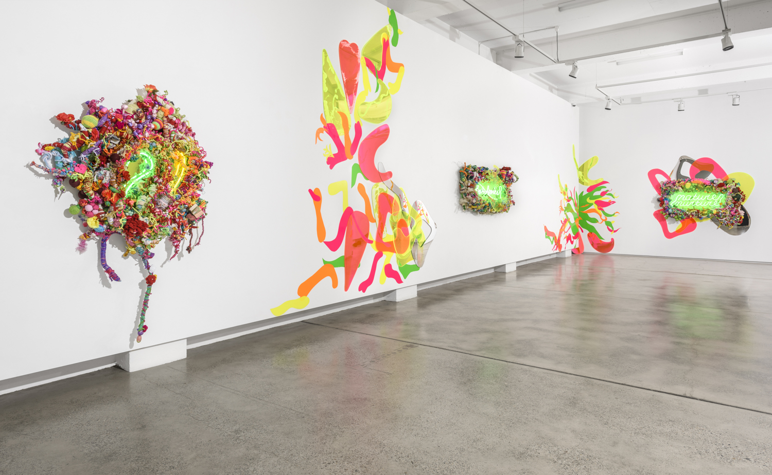
Hiromi Tango, Fluorescence (Installation View), 2015. Courtesy the Artist and Sullivan+Strumpf, Sydney.

MARCH 15, 2018, DUBAI, UNITED ARAB EMIRATES – The full program for the 6th edition of the Sheikha Manal Little Artists Program was announced today, including the Apprentice Artists for the annual on-site workshops at Art Dubai, the popular Discovery Tours for children and teenagers at the fair, as well as a growing number of schools taking part in the Artists-in-Schools Initiative.

Held under the patronage of Her Highness Sheikha Manal bint Mohammed bin Rashid Al Maktoum, President of the UAE Gender Balance Council, President of Dubai Women Establishment, and wife of His Highness Sheikh Mansour bin Zayed Al Nahyan, UAE Deputy Prime Minister and Minister of Presidential Affairs, the program is a partnership between The Cultural Office of Her Highness Sheikha Manal bint Mohammed bin Rashid Al Maktoum and Art Dubai, offering a unique educational opportunity for UAE-based children and teenagers and encouraging them to excel in the arts. The program is part of The Cultural Office and Art Dubai’s longstanding commitment to education and the development of the UAE’s cultural landscape.

On-Site Workshops & Apprentice Artists
The Sheikha Manal Little Artists Program introduces inventive art educational approaches, experimental teaching methods, and pedagogical explorations through a number of artist-lead workshops held in Dubai-based schools and at Art Dubai. Japanese-Australian artist Hiromi Tango will be the lead artist for the 2018 edition of the program, and present Healing Garden, an interactive installation that invites children to participate in creating a nurturing environment based on local plants and flowers. She will be joined by 5 Apprentice Artists: Zahia Abdul, Fatima Afghan, Taqwa Al Naqbi, Mohammed Khalid and Melis Malatani.

The Apprentice Artists program offers an excellent opportunity for UAE-based artists to develop their craft and advance in their art career, capitalizing on the prospect of working with an internationally renowned artist specializing in children’s education, such as Hiromi Tango. Apprentice Artists will assist the lead artist in devising the program of workshops, while having the opportunity to exchange ideas, and develop a practice that includes teaching/learning. There will also be possibilities to lead some workshops during Art Dubai.

Bookings for the on-site workshops are now open and available here.

Discovery Tours
The 6th edition of the program will also see the return of its sought-after Discovery Tours, led by UAE-based and international artists and art educators. The tailor-made tours are designed to enable young children to discover key pieces around the fair, with the works brought alive via thematic activity maps and the storytelling of the guides. The tours are split across three age groups (ages 5-7), (ages 8-12) and (ages 13-17).

Sign-up for the Discovery Tours here.

Artists-in-Schools Initiative
Part of the Sheikha Manal Little Artists Program, the Artists in Schools Initiative, taking place on March 18, 19 and 20 will feature workshops that play with a variation of the Healing Garden theme, which is presented at the fair, offering a unique educational opportunity for UAE-based schoolchildren, and encouraging them to engage with and excel in the arts.

The popularity of the initiative manifests itself in a growing number of schools taking part in the program. This year’s participating schools include Jumeirah English Speaking School (Arabian Ranches), Latifa School for Girls, Rashid School for Boys, Repton School and Jumeirah Model School.

Al Maha Al Bastaki, Director of The Cultural Office, commented: “With an ever growing program of on-site workshops, Discovery Tours and the Artists-in-Schools Initiative, we are immensely proud to see the Sheikha Manal Little Artists Program launches its 6th edition this year. We are delighted to see the positive reception of the program by children and artists alike and are looking forward to strengthen our efforts in children’s art education in the near future.”

The Sheikha Manal Little Artists Program is part of Art Dubai’s wider educational programing, providing opportunities for school-age children, college students and graduates through to collectors and art-enthusiasts. Other Art Dubai educational programs include the fair’s critically acclaimed Global Art Forum, the largest talks program in the Middle East and Asia, recognized as a leading international platform for engaging cultural debate, Campus Art Dubai, an art school for artists, curators, writers, designers and cultural producers based in the UAE, and the Art Dubai Fellowship, a fellowship that brings together exceptional young curators and writers from the Arab world. More information on Art Dubai’s programing is available here.

—END—

MEDIA CONTACT
Nicole Kanne Reem Sadek
Art Dubai The Cultural Office
nicole@artdubai.ae reem.sadek@dwe.gov.ae

NOTES TO EDITORS

About The Cultural Office
The Cultural Office of Her Highness Sheikha Manal bint Mohammed bin Rashid Al Maktoum was established in 2013 to serve as a leading platform to develop and activate substantial art movements as milestones within the region that will fortify the UAE's standing as a global hub for culture and creativity. Combining the best art practices and concepts from around the world, then tailoring it to respect and preserve our legacy and culture in the Arab world for International recognition, the projects undertaken by The Cultural Office are carefully selected to help raise the profile of the pool of talents existing in the region, based on the understanding that the cultivation and training of emerging talent is essential to ensure sustained excellence in the arts.
theculturaloffice.ae

About Art Dubai
A leading international art fair, Art Dubai is the preeminent place to interact with Contemporary art from the Middle East, North Africa and South Asia. For its 12th edition Art Dubai presents a unique line-up of 105 galleries from 48 countries, reaffirming the fair's position as a place of discovery with galleries from new markets rarely seen on the international stage exhibiting alongside leading galleries from established art centers. It will also showcase the largest edition of Art Dubai Modern – the world’s only platform that exhibits museum-quality Modern works from the MENASA region, alongside the annual Modern Symposium of talks on the lives and legacies of artists operating in these regions in the 20th century.

Art Dubai 2018 inaugurates a new gallery section – Residents – that welcomes spaces whose artists will complete a residency in the UAE with work created during this period exhibited at the fair.

Beyond the gallery halls, the fair once again hosts an extensive collateral program including the 10th anniversary of The Abraaj Group Art Prize, the Global Art Forum that takes on the theme of automation, and a series of commissions including the artist collective GCC, which will welcome audiences to Good Morning GCC at the fair and an engaging after-hours program, including private visits to collections and to cultural institutions across the United Arab Emirates.

In addition to its March programming, the fair aims to continue to grow the cultural fabric of the city and the region with year-round engagement including the art school Campus Art Dubai, an internship program aimed at supporting the next generation of art practitioners and professionals, and Art Dubai Portraits, a film series casting light on MENASA artists and their practices.

Art Dubai is held in partnership with The Abraaj Group. The fair is sponsored by Julius Baer and Piaget, with Madinat Jumeirah as the home of the event. The Dubai Culture & Arts Authority (Dubai Culture) is a strategic partner of Art Dubai and supports the fair’s year-round education program. MiSK Art Institute is the exclusive partner of Art Dubai Modern.

artdubai.ae
Twitter | Facebook | Instagram | #ArtDubai2018

