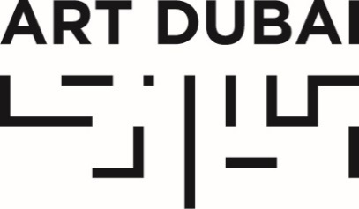

Press Release
Date of issue: October 10, 2018

CHLOE VAITSOU TO JOIN ART DUBAI AS INTERNATIONAL DIRECTOR

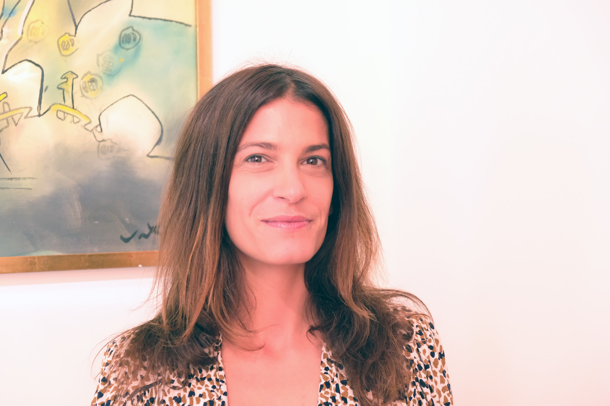
Chloe Vaitsou

October 10, 2018, Dubai, United Arab Emirates – Art Dubai today announced that Chloe Vaitsou will join Art Dubai as International Director, starting her position in December 2018. The 2019 edition of Art Dubai will take place at Madinat Jumeirah from March 20-23, 2019.

Vaitsou will work alongside Artistic Director Pablo del Val and together they will oversee the direction of the fair. Her focus will be to lead on the development and delivery of an innovative and ambitious VIP and audience strategy, as well as growing the international profile of Art Dubai by launching new commercial and non-commercial initiatives.
Vaitsou has worked on a wide range of cultural projects in different capacities. Having advised on private art collections over the past decade, she most recently held the position of Head of Audience Development for Frieze Fairs, where she oversaw the strategic development and execution of the global VIP strategy for Frieze London, Frieze Masters & Frieze New York. Curatorial projects have included exhibitions at the Institute of Contemporary Arts (ICA) in London and the Athens Biennale in Greece. Additionally, she has led cultural tactical planning and brand development projects, as well as audience engagement programmes in the EMEA region, the US and Asia for luxury clients. Vaitsou holds a BA from Brown University and obtained her MA from the Courtauld Institute of Art in London.

Commenting on the announcement, Vaitsou said: “I am thrilled to be joining the Art Dubai team as International Director. This is an exciting time for Art Dubai and I look forward to working alongside Pablo and the team to further build Art Dubai’s position as one of the world’s leading and most innovative art fairs.”

Benedict Floyd, CEO of the Art Dubai Group added: “We are delighted to welcome Chloe to Art Dubai where she will add great value to our already highly experienced team. Chloe brings extensive experience of working with top-class collectors and institutions at a particularly exciting time for the fair”.

NEW AND RETURNING PARTNERS AND SPONSORS

The Office of Public and Cultural Diplomacy (OPCD) will be working with Art Dubai on a number of its programmes, namely Residents and the Global Art Forum, which will travel to a number of destinations globally over the next three years, with the next iteration taking place in Tokyo in November 2018.

Luxury watchmaker and jeweler Piaget – part of the Richemont Group - recently renewed a long-term partnership with Art Dubai. Swiss private banking group Julius Baer will continue its partnership with the fair and further increase its presence with a new lounge. BMW will return with an increased activation as the exclusive car partner and, after successfully launching the Ithra Art Prize earlier this year, the fair will also work again on producing the second edition. Other partners include Madinat Jumeirah, the home of the fair, the Dubai Culture and Arts Authority (Dubai Culture), which continues to support the fair’s non-commercial programming as well as the Misk Art Institute that will announce its activation at the fair in the coming months.

EXPANDED PROGRAMME

Three guest curators have been appointed for the fair’s 2019 edition. Hailing from France, Brazil and the United Arab Emirates respectively, Élise Atangana, Fernanda Brenner and Munira Al Sayegh will offer fresh perspectives on non-western discourse, and help to cement Dubai’s position as a truly global cultural meeting point.

For the 2019 fair, Art Dubai’s Modern and Contemporary sections will be presented in dialogue, offering a more cohesive reading of the region’s art history. The Residents section will return for a larger second edition, with a focus on Latin America. Brazilian arts professional Fernanda Brenner will co-curate Residents alongside Emirati curator Munira Al Sayegh.

2019 will also see the inaugural edition of a new section for 2019. Bawwaba, which takes its title from the Arabic word for ‘gateway’, will focus on different geographies and viewpoints that are distinct from the Western canon. Bawwaba will feature works by individual artists from, based in, or focused on the Middle East, Africa, Central and South Asia and Latin America. The first edition of Bawwaba will be guest curated by French-Cameroonian curator, Élise Atangana, whose projects focus on the relationship between physical and virtual mobilities, and contemporary living.
This revamped structure has resulted in a record number of gallery applications for Art Dubai 2019. The list of participating galleries will be announced in November 2018.

—END—

MEDIA CONTACTS

Nicole Kanne
Art Dubai
nicole@artdubai.ae

Jasmine Hersee
Sutton PR
Jasmine@suttonpr.com

NOTES TO EDITORS

About Art Dubai
Taking its distinct identity from a one-of-a-kind line-up of galleries from across the world, Art Dubai is the world’s most globally diverse art fair. Featuring four gallery sections – Contemporary, Modern, Residents and Bawwaba, Art Dubai is also the leading fair for art from the region, with its Modern section being the only commercial platform for museum-quality Modern works from the Middle East, Africa and South Asia.

Mirroring Dubai’s position as a center of trade and junction between different cultures, Art Dubai further acts as a place of discovery for art from centers that are usually omitted from the Western mainstream dialogue on art; in geographical terms referring to a region, which has recently become known as the 'Global South'.

Art Dubai promotes regional art and artists by featuring a unique mix of programming and commissioned works, often in partnership with other regional institutions. Redefining the role an art fair should play, Art Dubai cultivates an ecosystem for art, education and thought leadership beyond the commercial aspects of the fair. Two examples of this are the fair's critically acclaimed Global Art Forum, the largest arts conference in the Middle East and Asia, and Campus Art Dubai a one-of-a-kind educational programme in the UAE.

The fair further acts as a grassroots-type institution for art and art production through initiatives such as Residents, a programme-cum-gallery section for international artists, who are invited to the UAE for a 6-week residency to immerse themselves in the local scene.

Acting as a digital extension of Art Dubai’s offering, Art Dubai Portraits is a commissioned film series profiling artists that are connected to the fair through its programming or participating galleries. This serves as a one-of-a-kind resource for curators and researchers working with art and artists from the region.

artdubai.ae

Twitter | Facebook | Instagram | #ArtDubai2019

About Chloe Vaitsou
Chloe Vaitsou has worked on international commercial and non-commercial cultural projects in different capacities. Having advised on private art collections over the past decade, she most recently held the position of Head of Audience Development for Frieze Fairs, where she oversaw the strategic development and execution of the global VIP strategy for Frieze London, Frieze Masters & Frieze New York. Curatorial projects have included exhibitions at the Institute of Contemporary Arts (ICA) in London and the Athens Biennale in Greece. Additionally, she has led cultural tactical planning and brand development projects, as well as audience engagement programmes in the EMEA region, the US and Asia for luxury clients. Vaitsou holds a BA from Brown University and obtained her MA from the Courtauld Institute of Art in London.

