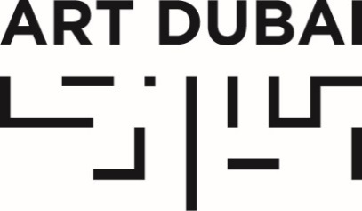

Press Release
Date of issue: November 7, 2018

ART DUBAI ANNOUNCES GALLERY LINE-UP AND NEW STRUCTURE FOR ITS 2019 EDITION

- Art Dubai’s 13th edition features galleries from 41 countries across 4 gallery sections.
- A new gallery section, Bawwaba, focused on solo projects from and about the Middle East, Central- and South Asia, Africa and Latin America will launch at the fair’s 2019 iteration.
- The Campus Art Dubai 7.0 cohort will exhibit works at the fair, presented alongside a range of young local initiatives in the UAE’s creative scene.
- Held under the patronage of HH Sheikh Mohammed bin Rashid Al Maktoum, Vice President and Prime Minister of the UAE and Ruler of Dubai, Art Dubai 2019 will take place from March 20-23, 2019 at Madinat Jumeirah, Dubai.

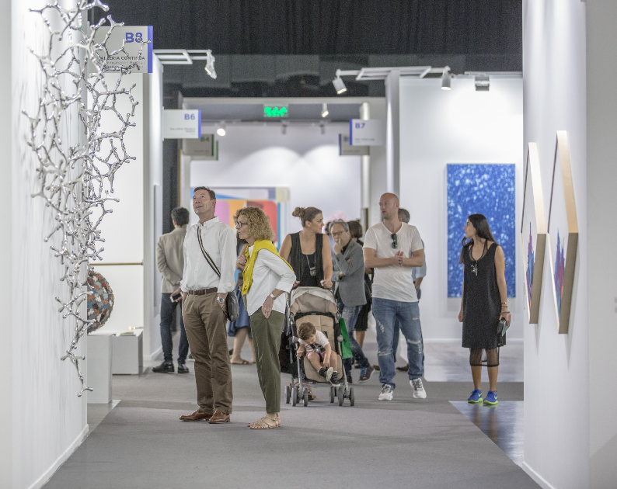

November 7, 2018, Dubai, United Arab Emirates – Art Dubai, the world’s most internationally diverse art fair, has today announced a full list of participating galleries, as well as details on the new gallery hall layout and programme for its 2019 edition. Showcasing +90 galleries from 41 countries, the fair will reconfirm Dubai’s position as a global meeting point for the arts.

Art Dubai’s new structure includes four main sections complementing each other, which will offer visitors greater access and deeper engagement with artists and galleries from non-Western geographies. The new format positions the Contemporary section as the core section of the fair, with Modern presented alongside the Contemporary galleries, enabling an elevated understanding of the region’s art history. The inaugural Bawwaba gallery section, taking its title from the Arabic word for ‘gateway’, focuses on different geographies and viewpoints from new markets and features solo presentations of works produced specifically for the fair. The programme-cum-gallery section Residents, a project inviting international artists for a 6-8 week residency in the UAE to produce new work and immerse themselves in the local art scene, will see its second edition in 2019 and will specifically focus on Latin America.

Continuing the fair’s commitment to supporting the development of the local art scene, Art Dubai will dedicate a new section in the fair to showcase young, local projects from the fields of art, culture and creativity in the UAE, as well as produce an exhibition by the artists participating in Campus Art Dubai 7.0 programme.

Art Dubai’s Artistic Director Pablo del Val commented: “We aim to provide visitors to the 2019 fair a new experience by changing the gallery hall structure to allow for a more curated presentation with larger booths, enable a more cohesive reading of the different works on show, and highlight one of Art Dubai’s key focal points – art from and focused on the Global South. With this new format, we received a record number of gallery applications and we are delighted to welcome both long-time returning galleries as well as newcomers, including first-time exhibitors from Cameroon and Colombia.”

The fair is sponsored by Julius Baer and Piaget, with Madinat Jumeirah as the home of the event. The Dubai Culture & Arts Authority (Dubai Culture) is a strategic partner of Art Dubai and supports the fair’s year-round education programme. BMW is the exclusive car partner of Art Dubai.

CONTEMPORARY & MODERN

Reflecting the new structure of the fair, the participating 69 Contemporary and Modern galleries will be presented alongside one another in one of the two main gallery halls, with Modern taking place in a specific designated area, allowing for a better reading of the art history and contextualization of Contemporary art from the region.

The 2019 Contemporary section will see a strong contingent of returning galleries from Europe and Asia, including Victoria Miro (London, Venice), Galleria Continua (San Gimignano, Beijing, Les Moulins, La Habana), Experimenter (Kolkata), Ota Fine Arts (Tokyo), Galerie Templon (Brussels, Paris), Galleria Franco Noero (Turin), In Situ – Fabienne Leclerc (Paris) and Galerie Krinzinger (Vienna).

Art Dubai Contemporary will also welcome back several prominent galleries from the region, including Sfeir-Semler Gallery (Hamburg, Beirut), ATHR Gallery (Jeddah), Dastan’s Basement (Tehran) as well as 10 Dubai-based galleries, including Gallery Isabelle van den Eynde, The Third Line and Green Art.

In addition, the fair will feature a prominent line-up of first-time exhibitors from the region and beyond, including Sprüth Magers (Berlin, London, Los Angeles), Andersen’s (Copenhagen), Galerie MAM (Douala) and Akar Prakar (Kolkata, New Delhi, Jaipur).

The new gallery hall structure will also allow the Modern galleries to create exhibitions in a larger booth space, allowing for more curated presentations. Highlights among the Modern Galleries include DAG (New York, Delhi, Mumbai), Gallery One (Ramallah), Dhoomimal Gallery (New Delhi) and Grosvenor Gallery (London).

View the full list of galleries selected for Art Dubai Contemporary 2019 here.
View the full list of galleries selected for Art Dubai Modern 2019 here.

BAWWABA

Launching at the upcoming edition of Art Dubai, Bawwaba is a unique gallery section, located within the main gallery halls. The section will feature projects by individual artists or galleries, located in or focused on the Middle East, Africa, Central and South Asia as well as Latin America.

The inaugural edition of Bawwaba will be curated by French-Cameroonian curator Élise Atangana, and focus on highly conceptual works including videos, installations and murals. The section aims to give visitors a curated reading of the Global South, acting, as its name suggests, as a gateway to current artistic developments from these regions.

Exhibiting galleries in the first edition of Bawwaba will include Guzo Art Projects (Addis Ababa) exhibiting Kenyan artist Wanja Kimani, Canvas Gallery (Karachi) with works by Kuwaiti artist Hamra Abbas as well as a show of works by Turkish artist Gözde Ilkin by Gypsum Gallery (Cairo).

View the full list of galleries selected for Bawwaba 2019 here.

RESIDENTS

Following the success of its inaugural edition, Residents will return for its second iteration in 2019, with 12 exhibiting galleries. The section will move from its initial location between the two main gallery halls to Mina A’Salam, and focuses solely on Latin America in 2019. Acting as the Curators for the 2019 edition, Fernanda Brenner (Brazil) and Munira Al Sayegh (UAE) selected 12 galleries who in turn nominated specific artists to spend 6-8 weeks in the UAE, who will be able to immerse themselves in the local art scene, producing art to populate their booths at the fair.

The geographic focus for Residents results in further streamlining the visitors experience across all sections. It will, crucially, allow dialogue to take place between practices in the UAE and Latin America.

Exhibiting galleries in the 2019 edition of Residents will include Galeria Revolver (Buenos Aires, Lima) exhibiting Jerry B. Martin, Mendes Wood DM (São Paulo, Brussels, New York), with works by Luiz Roque to Dubai, as well as Luisa Strina (São Paulo), showing Brazilian artist Alexandre da Cunha.

Residents is held in partnership with the Office of Public and Cultural Diplomacy (OPCD).

View the full list of galleries selected for Residents 2019 here.

—END—

MEDIA CONTACTS

UAE and regional media: International media:
Nicole Kanne Jasmine Hersee
Art Dubai Sutton PR
nicole@artdubai.ae Jasmine@suttonpr.com

NOTES TO EDITORS

About Art Dubai
Art Dubai is a leading international art fair as well as the world’s leading platform for Contemporary and Modern art from the MENASA region.

Mirroring Dubai’s position as a center of trade and junction between different cultures, Art Dubai further acts as a place of discovery for art from centers that are usually omitted from the Western mainstream dialogue on art; in geographical terms referring to a region, which has recently become known as the 'Global South'.

Art Dubai promotes regional art and artists by featuring a unique mix of programming and commissioned works, often in partnership with other regional institutions. Redefining the role an art fair should play, Art Dubai cultivates an ecosystem for art, education and thought leadership beyond the commercial aspects of the fair. Two examples of this are the fair's critically acclaimed Global Art Forum, the largest arts conference in the Middle East and Asia, and Campus Art Dubai a one-of-a-kind educational programme in the UAE.

The fair further acts as a grassroots-type institution for art and art production through initiatives such as Residents, a programme-cum-gallery section for international artists, who are invited to the UAE for a 6-8 week residency to immerse themselves in the local scene.

Acting as a digital extension of Art Dubai’s offering, Art Dubai Portraits is a commissioned film series profiling artists that are connected to the fair through its programming or participating galleries. This serves as a one-of-a-kind resource for curators and researchers working with art and artists from the region.

The fair is sponsored by Julius Baer and Piaget, with Madinat Jumeirah as the home of the event. The Dubai Culture & Arts Authority (Dubai Culture) is a strategic partner of Art Dubai and supports the fair’s year-round education programme. BMW is the exclusive car partner of Art Dubai.

artdubai.ae

Twitter | Facebook | Instagram | #ArtDubai2019

