Press Release
Date of issue: January 23 2019

SALLY CURCIO ANNOUNCED AS LEAD ARTIST FOR THE SEVENTH EDITION OF THE SHEIKHA MANAL LITTLE ARTISTS PROGRAM

Taking place at Art Dubai in March, this year’s program will be themed ‘Creating New Worlds’

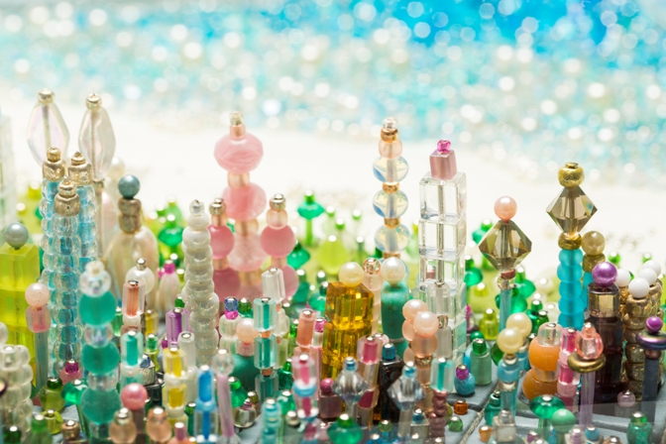
Sally Curcio, Miami (Detail), 2009

DUBAI, UNITED ARAB EMIRATES, January 23, 2019 – Art Dubai and The Cultural Office of Her Highness Sheikha Manal bint Mohammed bin Rashid Al Maktoum announced today the artist and theme for the seventh edition of the Sheikha Manal Little Artists Program. American artist Sally Curcio will be the lead artist for the upcoming iteration, themed Creating New Worlds, and taking place at Art Dubai from March 20-23, 2019.

Held under the patronage of Her Highness Sheikha Manal bint Mohammed bin Rashid Al Maktoum, President of UAE Gender Balance Council, President of Dubai Women Establishment, and wife of His Highness Sheikh Mansour bin Zayed Al Nahyan, Deputy Prime Minister and Minister of Presidential Affairs UAE, the program is a partnership between The Cultural Office and Art Dubai, offering a unique educational opportunity for UAE-based children and teenagers, and encouraging them to excel in the arts. The program is part of Art Dubai’s longstanding commitment to education and the development of the UAE’s cultural landscape.

With Creating New Worlds, lead artist Sally Curcio will invite children and teenagers to explore and create cityscapes and urban landscapes through the use of miniatures and prototypes, allowing them to create their own imaginative utopia. Curcio’s goal with this project is to motivate an inventive spirit, cooperation as well as to encourage participants to explore how different materials can be composed to create new imagined environments. Materials such as colored beads, balls, pipe cleaners, blocks, bottle caps, and other found and recycled material will be used to create the new worlds, and their use for representing cityscapes of varying scale and perspective enriches idea development and creative processes that are of value in a range of artistic and work endeavors.

Al Maha Al Bastaki, Director of The Cultural Office, commented: “Her Highness Sheikha Manal bint Mohammed bin Rashid Al Maktoum’s unwavering commitment to building and developing art education for children and the youth in the UAE manifests itself in a variety of projects throughout the year, with the Sheikha Manal Little Artists Program, going into its seventh edition this year, being one of the key initiatives in the ecosystem of art education in the UAE”.

“We are delighted to announce Sally Curcio as the lead artist for the program’s 2019 edition and look forward to seeing her ignite imagination and an inventive spirit in all participating children and youth taking part”, Al Bastaki added.

Newly appointed lead artist Sally Curcio said: “I’m delighted to have been chosen as the lead artist for the seventh edition of this prestigious program. One of the key areas of focus in my work is engaging with children and teenagers, and I look forward to working with them on creating their own little utopias, while learning how to use their imagination, cooperate with each other and employ an inventive spirit.”

The full program for the 7th edition of the Sheikha Manal Little Artists Program will include on-site workshops at Art Dubai, the popular Discovery Tours for children and teenagers at the fair, as well as the Artists-in-Schools Initiative. Due to the growing popularity of the program, the number of public workshops will increase by 25% for the upcoming edition and feature daily Discovery Tours.

Further details of the program will be announced in the coming weeks.

—END—

MEDIA CONTACT
Ciara Phillips Reem Sadek
Art Dubai The Cultural Office
ciara@artdubai.ae reem.sadek@dwe.gov.ae

NOTES TO EDITORS

About The Artist

Sally Curcio has, over the past 18 years, created art that captures the imagination of both children and adults, by making playful miniature worlds that are both visually complex and accessible. She calls these works Bubble Sculptures, as the worlds are enclosed in a protective, transparent bubble. Many associations can be brought to the Bubble Sculptures as they summon nostalgia for the innocent perspectives of childhood, suggest the fragility of environments, and offer examples of imagined and utopian possibilities. As we long for a more harmonious world, Curcio’s Bubble Sculptures counsel an openness to what may be possible.
Sally Curcio has exhibited her work throughout the United States and internationally. Her work is in the permanent collections of Smith College Museum of Art, the Fitchburg Art Museum, NYU Langone Hospital, and the Hassenfeld Children’s Hospital, NYC. She has exhibited her work at the Peabody Essex Museum, the Bruce Museum, and the Children’s Museum of the Arts, NYC.

About the Sheikha Manal Little Artists Program
The Sheikha Manal Little Artists Program is held under the patronage of Her Highness Sheikha Manal bint Mohammed bin Rashid Al Maktoum, President of UAE Gender Balance Council, President of Dubai Women Establishment, and wife of His Highness Sheikh Mansour bin Zayed Al Nahyan, Deputy Prime Minister and Minister of Presidential Affairs UAE.
The Sheikha Manal Little Artists Program was launched by The Cultural Office of Sheikha Manal bint Mohammed bin Rashid Al Maktoum in partnership with Art Dubai in 2013. Featuring artist-led workshops, tours and other projects, the program provides access to skills and ideas for UAE-based children and teenagers aged 5-17 with the long-term aim of encouraging young people to get involved and excel in the arts. In its sixth year, the program continues to grow including the artist-led ‘Artists in Schools Initiative’ giving exclusive opportunity to selected schools to experience the workshops on campus.

About The Cultural Office
The Cultural Office of Her Highness Sheikha Manal bint Mohammed bin Rashid Al Maktoum was established in 2013 to serve as a leading platform to develop and activate substantial art movements as milestones within the region that will fortify the UAE's standing as a global hub for culture and creativity. Combining the best art practices and concepts from around the world, then tailoring it to respect and preserve our legacy and culture in the Arab world for International recognition, the projects undertaken by The Cultural Office are carefully selected to help raise the profile of the pool of talents existing in the region, based on the understanding that the cultivation and training of emerging talent is essential to ensure sustained excellence in the arts.
theculturaloffice.ae

About Art Dubai
Art Dubai is a leading international art fair as well as the world’s leading platform for Contemporary and Modern art from the MENASA region.

Mirroring Dubai’s position as a centre of trade and junction between different cultures, Art Dubai further acts as a place of discovery for art from centres that are usually omitted from the Western mainstream dialogue on art; in geographical terms referring to a region, which has recently become known as the 'Global South'.

Art Dubai promotes regional art and artists by featuring a unique mix of programming and commissioned works, often in partnership with other regional institutions. Redefining the role an art fair should play, Art Dubai cultivates an ecosystem for art, education and thought leadership beyond the commercial aspects of the fair. Two examples of this are the fair's critically acclaimed Global Art Forum, the largest arts conference in the Middle East and Asia, and Campus Art Dubai a one-of-a-kind educational programme in the UAE.

The fair further acts as a grassroots-type institution for art and art production through initiatives such as Residents, a programme-cum-gallery section for international artists, who are invited to the UAE for a 6-8 week residency to immerse themselves in the local scene.

Acting as a digital extension of Art Dubai’s offering, Art Dubai Portraits is a commissioned film series profiling artists that are connected to the fair through its programming or participating galleries. This serves as a one-of-a-kind resource for curators and researchers working with art and artists from the region.

The fair is sponsored by Julius Baer and Piaget, with Madinat Jumeirah as the home of the event. The Dubai Culture & Arts Authority (Dubai Culture) is a strategic partner of Art Dubai and supports the fair’s year-round education programme. BMW is the exclusive car partner of Art Dubai.

artdubai.ae

Twitter | Facebook | Instagram | #ArtDubai2019

