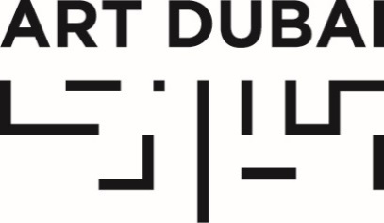
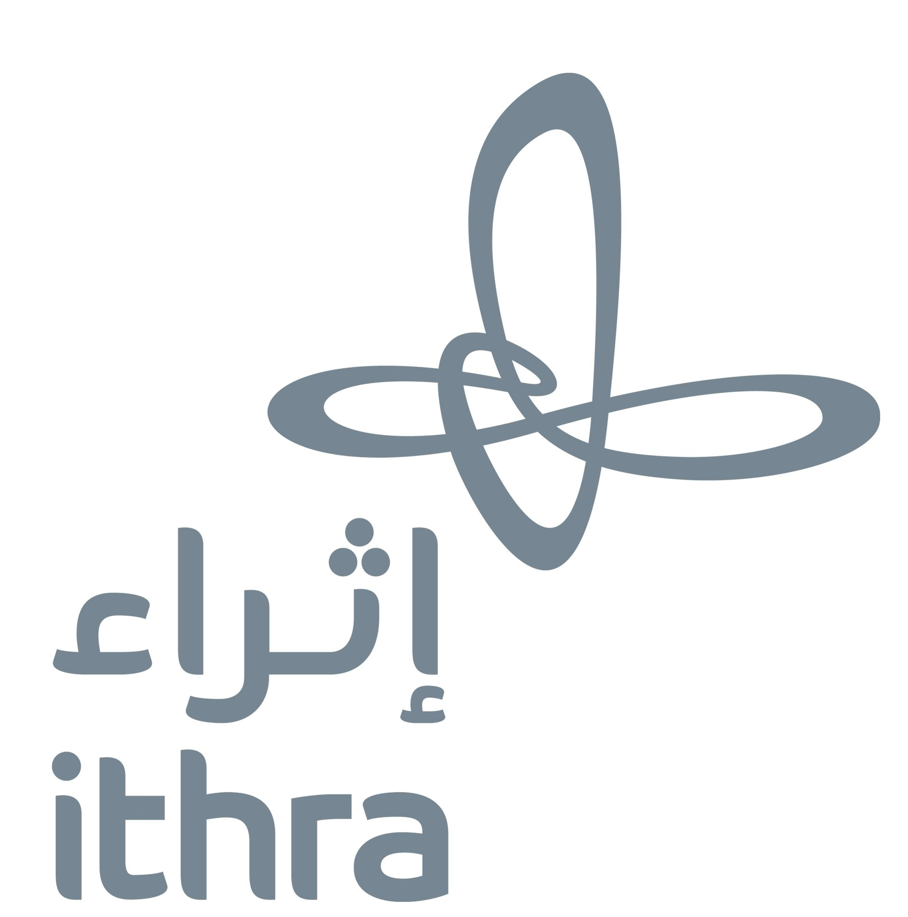

For immediate release
January 30, 2019

DANIAH ALSALEH ANNOUNCED AS WINNER OF
THE SECOND EDITION OF THE ITHRA ART PRIZE,
A JOINT INITIATIVE BETWEEN THE KING ABDULAZIZ CENTER FOR WORLD CULTURE AND ART DUBAI SET UP TO SUPPORT AND PROMOTE SAUDI ARTISTIC TALENT

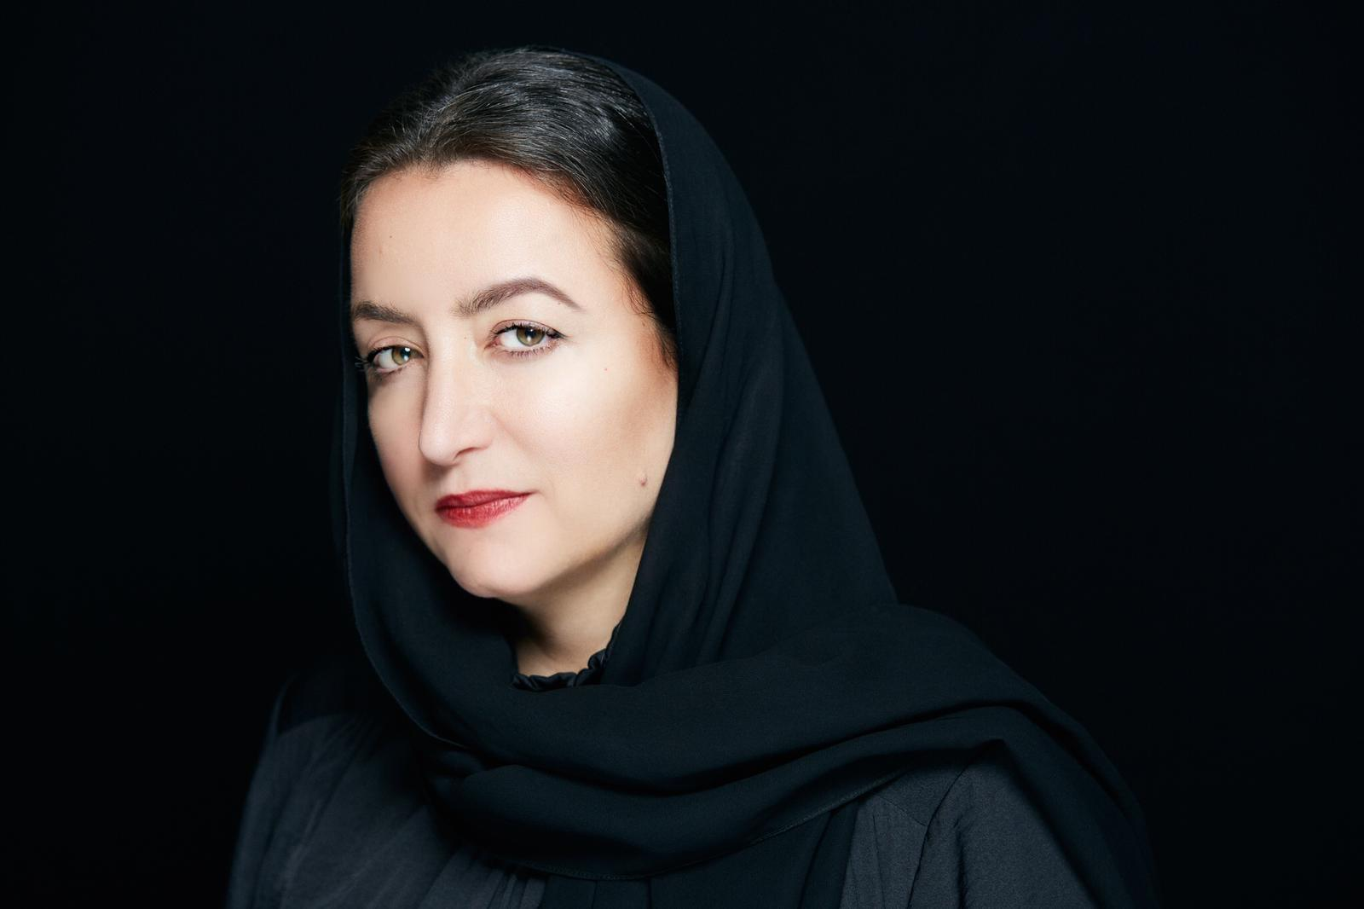
Ithra Art Prize 2019 winner, Daniah Alsaleh

JANUARY 30, 2019, DHAHRAN, SAUDI ARABIA – The King Abdulaziz Center for World Culture (Ithra) and Art Dubai announce today London-based Saudi Arabian artist Daniah Alsaleh as the winner of the second edition of the Ithra Art Prize.

The initiative was launched in 2017 by Ithra in partnership with Art Dubai, the aim of Ithra Art Prize is to support and promote emerging Saudi contemporary artists on a truly global platform.

All Saudi and Saudi-based artists and collectives were invited to submit proposals via an annual open call, with the prize winner receiving up to $100,000 to realize their new artwork, which will be first shown at Art Dubai before moving to Ithra as part of the Center’s permanent collection. The inaugural winner, Sharjah-based conceptual artist Ayman Zedani’s commission, Meem, was exhibited at Art Dubai last year.

A testament to the popularity and impact of the Prize, the second edition of the competition received twice the number of applications, with Daniah Alsaleh’s winning proposal chosen by a selection committee made up of the curatorial team at Ithra and international art experts, Mona Khazindar and Anna Seaman.

Born and raised in Riyadh, Alsaleh (b. 1970) is currently completing a Masters in Fine Art in Computational Art at Goldsmiths University of London. Through her work, she addresses notions of the unobtrusive, the ordinary and the common, using geometry and pattern as a form of expression, and crossing disciplines from painting to developing generative art processes with code.

Described by the selection committee as “powerful and thoroughly captivating”, Alsaleh’s proposal explores the structure and complexities of language, deconstructing it to its smaller unit of sound, the phoneme, and lends the large-scale multimedia artwork its name: Sawtam, the Arabic translation of “phoneme”.

Commenting on the announcement, Ali Al-Mutairi, Director of the King Abdulaziz Center for World Culture (Ithra) said: “After the successful opening of the Center last year, we are thrilled to see the Ithra Art Prize proceed in its second edition. Our key commitment remains - to support and promote Saudi- and Saudi-based artistic talent - and we are delighted to partner with Art Dubai once more on this Prize. The committee’s response to Daniah’s work was unanimous and we are looking forward to supporting her closely as she works on the commissions and look forward to its reveal in March.”

Winning artist Daniah Alsaleh added: “I am thrilled to have been chosen as the winner for the second edition of the Ithra Art Prize and look forward to be showcasing my work at Art Dubai. With its many initiatives to support Saudi artists like myself, Ithra has made a tangible difference in the development of Saudi Arabia’s art scene and I’m honored and humbled to be associated with such a prestigious project and organization.”

Alsaleh will spend the next months finlazing Sawtam, before being exhibited during Art Dubai and then joining Ithra’s permanent art collection.

Ithra, a cultural and creative hub based in Dhahran, Saudi Arabia, offers programs and compelling experiences while enhancing and showcasing local and global talents. It proudly made TIME Magazine’s 2018 list of one of the world’s best 100 places to visit.

—END—

MEDIA CONTACTS
Mona Al Shehri
Media Relations, Ithra
mona.shehri@aramco.com
T: +966 504967179

Ciara Phillips
Acting Head of Communications and Outreach, Art Dubai
ciara@artduabi.ae
T +971 5 5686 9488

NOTES TO EDITORS

About the Artist: Daniah Alsaleh
Daniah Alsaleh was born and raised in Riyadh and gained her Bachelor’s degree in Computer Applications at King Saud University. She studied painting at Dar Safia Bin Zagr in Jeddah and has attended many art courses abroad. Her work tackles notions of the unobtrusive, the ordinary and the common and her approach is to deconstruct and rearrange the obvious, to make the invisible visible, and manifest a space for reflection with new ways of seeing. She uses geometry and pattern making in her form of expression by mixing tangible and intangible objects of art, crossing disciplines from traditional mediums of painting to developing generative art processes with code. Alsaleh is currently doing her MFA in computational art at Goldsmiths University of London.

About the Ithra Art Prize
Launched in 2017 by the King Abdulaziz Center for World Culture (Ithra) in collaboration with Art Dubai, the Prize is awarded to emerging Saudi and Saudi-based talent in contemporary art as a means to fund, promote and offer Saudi artists a global platform. Sharjah-based, Saudi Arabian artist Ayman Zedani was the winner of the first edition of the Prize and will be part of the jury for the second edition of the Prize. The selection committee is made up of Saudi as well as international experts, including members of the Center and Art Dubai. As part of a collaboration between Ithra and Art Dubai, the winning work is unveiled at Art Dubai each year, and subsequently joins Ithra’s prestigious permanent collection.

About the King Abdulaziz Center for World Culture
The King Abdulaziz Center for World Culture’s building with its unique architecture rises as a shining beacon of knowledge in Dhahran’s skyline. The building, which is an initiative by Saudi Aramco, is significantly located near the Prosperity Well where oil was first discovered in commercial quantities in the Kingdom of Saudi Arabia. The purpose of this ambitious initiative is to accelerate the Kingdom’s transformation into a knowledge-based economy as envisioned by HM King Abdullah who laid the foundation stone for this iconic building.

The Center is the first incubator of knowledge of its kind in the Kingdom of Saudi Arabia. It brings together under its roof many programs that aim to create a positive and tangible impact in the fields of knowledge and culture by preparing the national talents for the knowledge-based and innovation-based creative industries.

The Center features a modern architectural design, state-of-the-art technologies, unique learning tools, and enriching programs. It is an important platform for explorers, intellectuals, innovators, and leaders. The Center – a diverse cultural space – has a 21st century Library, an Idea Lab, a Children Museum, an Oasis for children, a Four-Gallery Museum, an Archives Gallery, an Energy Exhibit, a Knowledge Tower, a Great Hall, a Theater and a Cinema, which stands at its heart to offer educational programs that cater to all age groups. The Center’s programs were all designed to inspire the community, enrich the culture, and support our community which is taking steady steps toward establishing a knowledge-based economy.

About Art Dubai
Art Dubai is a leading international art fair as well as the world’s leading platform for Contemporary and Modern art from the MENASA region.

Mirroring Dubai’s position as a centre of trade and junction between different cultures, Art Dubai further acts as a place of discovery for art from centres that are usually omitted from the Western mainstream dialogue on art; in geographical terms referring to a region, which has recently become known as the 'Global South'.

Art Dubai promotes regional art and artists by featuring a unique mix of programming and commissioned works, often in partnership with other regional institutions. Redefining the role an art fair should play, Art Dubai cultivates an ecosystem for art, education and thought leadership beyond the commercial aspects of the fair. Two examples of this are the fair's critically acclaimed Global Art Forum, the largest arts conference in the Middle East and Asia, and Campus Art Dubai a one-of-a-kind educational programme in the UAE.

The fair further acts as a grassroots-type institution for art and art production through initiatives such as Residents, a programme-cum-gallery section for international artists, who are invited to the UAE for a 6-8 week residency to immerse themselves in the local scene.

Acting as a digital extension of Art Dubai’s offering, Art Dubai Portraits is a commissioned film series profiling artists that are connected to the fair through its programming or participating galleries. This serves as a one-of-a-kind resource for curators and researchers working with art and artists from the region.

The fair is sponsored by Julius Baer and Piaget, with Madinat Jumeirah as the home of the event. The Dubai Culture & Arts Authority (Dubai Culture) is a strategic partner of Art Dubai and supports the fair’s year-round education programme. BMW is the exclusive car partner of Art Dubai.

artdubai.ae

Twitter | Facebook | Instagram | #ArtDubai2019

