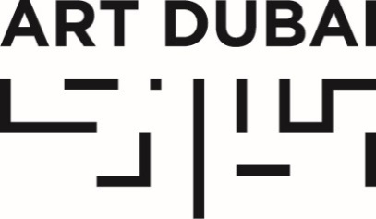

Press Release

ART DUBAI OPENS TOMORROW, MARCH 20, 2019

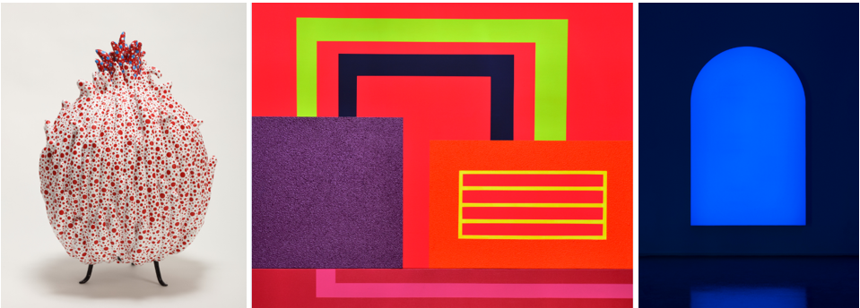Images left to right: Yayoi Kusama, Flower C, 2018, Sewn stuffed fabric, paint, metal, H50 x 37 x 37 cm, Courtesy of Ota Fine Arts Shanghai / Singapore / Tokyo; Peter Halley, Collocation, 2005, acrylic, day-glo acrylic ,pearlescent acrylic and roll a-tex on canvas, 163 x 205 Courtesy of CUSTOT; Pamela Rosenkranz, Alien Blue Window (Atris, Via San Tomaso 53), 2017, Lighttex, Blue LEDs, Anodized Frame, Remote Control, USB Dongle, 215 x 137,7 cm, Courtesy: © Pamela Rosenkranz Courtesy Sprüth Magers Photography: Mark Asekhame
- The 13th edition presents the fair’s most extensive and internationally diverse programme to date
- Across four gallery sections, 92 galleries from 42 countries exhibit artworks by more than 500 artists, representing 80 nationalities
- New section UAE NOW spotlights independent home-grown subcultures, profiling UAE’s evolving and diverse cultural landscape
- A meeting point for art professionals and collectors from all over the world, Art Dubai hosts a record number of collectors and institutions and launches the inaugural Curators Ideas Exchange Programme

March 19, 2019, Dubai, United Arab Emirates – Held under the patronage of His Highness Sheikh Mohammed bin Rashid Al Maktoum, Vice President and Prime Minister of the UAE and Ruler of Dubai, Art Dubai, the world’s most internationally diverse art fair, returns for its 13th edition with its most extensive programme to date. The 2019 fair features 92 Contemporary and Modern galleries from 42 countries and one of the largest educational programming of any international art fair. Art Dubai 2019 runs from March 20-23 at Madinat Jumeirah.

Highlights include new gallery section Bawwaba, showcasing art from the Global South; UAE NOW - the first section of its kind - spotlighting local independent artist-run platforms and subcultures, their place in the UAE’s evolving landscape and contribution to creating new ways of thinking, theory and artistic movements; and Art Dubai’s internationally-acclaimed transdisciplinary arts summit, Global Art Forum (March 20-21).

Pablo del Val, Artistic Director of Art Dubai, said: “Art Dubai continues to develop original content to redefine what an art fair can be and contribute to the UAE and wider region’s cultural landscape. We represent an art world that is truly global and inclusive, rooted in artistic discovery and the promotion of new and alternative perspectives, community building, idea generation and cultural exchange. Geographies, galleries and artists, art typologies and thematics that are not often seen side-by-side, or even as part of the same conversation, will converge at the fair. We hope that new discoveries will be made and new synergies formed.”

The most global and diverse of art fairs, Art Dubai 2019 welcomes more than 500 artists representing 80 nationalities across its four gallery sections: Art Dubai Contemporary, Art Dubai Modern, Bawwaba and Residents. This year Art Dubai Contemporary features 59 galleries from 34 countries spread across its two gallery halls presenting work by some of the most notable contemporary artists working today. Art Dubai Modern - the only platform in the world dedicated to museum-quality works by 20th Century Modern masters from the Middle East, Africa and South Asia - is presented alongside Art Dubai Contemporary, giving context to the historical narrative being played out across the booths.

New gallery section Bawwaba sheds light on artist interrogations of the notion of the Global South via ten solo representations, addressing themes of global migration, socioeconomic structures and identity, reflecting the fair’s drive for diversity, inclusivity and discussion on new and alternative perspectives. Residents - Art Dubai’s unique annual residency programme – presents a focus on Latin America; 12 artists from the continent’s leading galleries were invited to the UAE for a 4-8 week residency, to immerse themselves in the local scene and produce new work for the fair. Complementing Residents is SOLAROCA, a commission by Brazilian collective OPAVIVARÁ!, which invites visitors to mingle and engage in intercultural dialogue.

Art Dubai’s talks programme includes the 13th edition of Global Art Forum that unites a diverse cast of speakers to examine the theme “School is a Factory?”; whilst Modern Symposium, under the title of “Cultural Hubs of Modernism”, attempts to map out the cultural shifts and trends instigated by modernity in four key cities in the region during the 20th century - Baghdad, Beirut, Dakar and Lahore – in a new ‘masterclass’ format.

As the highlight of the region’s cultural calendar and the world’s preeminent fair for Contemporary and Modern art from the Middle East region and geographies usually outside of art’s mainstream dialogue, Art Dubai’s programme has a tangible sense of community and cross-cultural exchange throughout. A meeting point for art professionals and collecting communities from all over the world, Art Dubai 2019 will host a record number of collectors and institutions and will launch the inaugural Curators Ideas Exchange Programme to introduce international curators to the UAE’s institutions and grassroots platforms.

Chloe Vaitsou, International Director of Art Dubai, said: “More than 130 international institutional representatives have confirmed attending the fair. This includes museum directors and curators from some of the world’s best museums, as well as independent professionals working in key non-profit organizations and biennales that are delivering some of the most cutting-edge exhibitions globally. Our goal is to strengthen and activate new local, regional and global networks that add value to the region’s cultural dialogue and the fair’s DNA as a multicultural hub. We hope to foster long-term conversations across continents and enable collaborative initiatives in the future.”

Art Dubai attracts a broad audience with its mandate to provide unrivalled access to the arts. Highlights include Sheikha Manal Little Artist Program, which encourages young people to get involved and excel in the arts; a performance programme developed by contemporary art institution Kunsthalle Lissabon as a celebration of togetherness; special exhibitions including ‘Tolerance, Has History’, an exhibition of rare photography from the Private Collection of His Highness Sheikh Hamdan bin Mohammed bin Rashid Al Maktoum, Crown Prince of Dubai, which presents a compelling visual narrative of the region in the 1960s and 1970s, and Campus Art Dubai’s group show, “Mirror Mirror on the Wall: Contemporary Art in the City”.

Art Dubai’s 2019 programme also includes new exhibitions by key partners of the fair. Julius Baer, the leading Swiss private banking group, has commissioned Chourouk Hriech, a French emerging artist of Moroccan origin, to create and curate ‘A Journey Drawn Through an Archaeology of the Present’, an exhibition with a focus on creating a bridge between Switzerland and Dubai. Piaget presents ‘L’Art de L’Or’ (‘The Art of Gold’), an exhibition dedicated to the work of gold, the ultimate expression of the Maison’s craftsmanship with an installation by French Maître d’Art Pierre Bonnefille. BMW Group Middle East brings one of its BMW Art Cars to the Middle East for the very first time. Exhibiting at Art Dubai will be the 1989 BMW M3 Group A racing version created by Australian painter Ken Done, with an exhibition in miniature form of all Art Car commissions since 1975.

Dubai Culture & Arts Authority is a strategic partner of Art Dubai and supports the fair’s year-round education programme. Global Art Forum and Residents is supported by the UAE Ministry of Foreign Affairs and International Cooperation.

The full list of Art Dubai 2019 galleries can be found here; and the fair’s online catalogue here.

The full programme of talks, family programming, performance and more is here.

PRESS INFORMATION and IMAGES, which will be updated throughout the fair, can be found here

—END—

MEDIA CONTACTS
Ciara Phillips, Acting Head of Communications and Outreach, Art Dubai | ciara@artdubai.ae

Local & regional PR agency: ASDA’A BCW | artdubai@bcw-global.com
International PR agency: Sutton PR | jasmine@suttonpr.com

NOTES TO EDITORS
Art Dubai is held at Madinat Jumeirah, Al Sufouh Road, Umm Suqeim,
Exit 39 (Interchange 4) from Sheikh Zayed Road, Dubai, UAE

Public opening hours
Thursday March 21: 2-9:30pm (last entrance at 9pm)
Friday March 22: 12-9:30pm (last entrance at 9pm)
Saturday March 23: 12-6:30pm (last entrance at 6pm)

About Art Dubai
Art Dubai is a leading international art fair as well as the world’s leading platform for Contemporary and Modern art from the MENASA region and is held under the patronage of His Highness Sheikh Mohammed bin Rashid Al Maktoum, Vice President and Prime Minister of the UAE and Ruler of Dubai.

Mirroring Dubai’s position as a centre of trade and junction between different cultures, Art Dubai further acts as a place of discovery for art from centres that are usually omitted from the Western mainstream dialogue on art; in geographical terms referring to a region which has recently become known as the 'Global South'.

Art Dubai promotes regional art and artists by featuring a unique mix of programming and commissioned works, often in partnership with other regional institutions. Redefining the role an art fair should play, Art Dubai cultivates an ecosystem for art, education and thought leadership beyond the commercial aspects of the fair. Two examples of this are the fair's critically acclaimed Global Art Forum, the largest arts conference in the Middle East and Asia, and Campus Art Dubai, a one-of-a-kind educational programme in the UAE.

The fair further acts as a grassroots-type institution for art and art production through initiatives such as Residents, an annual residency programme and gallery section for international artists who are invited to the UAE for a 4-8 week residency to immerse themselves in the local scene.

Acting as a digital extension of Art Dubai’s offering, Art Dubai Portraits is a commissioned film series profiling artists that are connected to the fair through its programming or participating galleries. This serves as a one-of-a-kind resource for curators and researchers working with art and artists from the region.

Art Dubai is sponsored by Julius Baer and Piaget, with Madinat Jumeirah as the home of the event. The Dubai Culture & Arts Authority (Dubai Culture) is a strategic partner of Art Dubai and supports the fair’s year-round education programme. Global Art Forum and Residents is supported by the UAE Ministry of Foreign Affairs and International Cooperation. BMW is the exclusive car partner of Art Dubai.

www.artdubai.ae | Twitter | Facebook | Instagram | #ArtDubai2019

